Thank you for your interest in joining the Redland City Council team.

A role with Council offers you the chance to improve lives and shape your own career… in a truly special place.

This Guide provides you with step by step instructions on how to use our Recruitment Portal to support our “Applying for a job with us” section on our Careers Website.

Table of Contents

1. Creating a Candidate Profile 2
2. Searching for and Applying for Jobs 5
3. Saving your application in draft and submitting later 10
4. Withdrawing an application 13
5. Create a Job Alert 14
6. Resetting your password 15
7. Updating your Resume and/or Cover Letter for an application 17
8. Receiving an Offer 19
9. Accepting an Offer 19
10. Declining an Offer 21
11. Clearing Cache & Cookies 22

Creating a Candidate Profile

- From Council’s Career Opportunities site, select the “Sign In link”
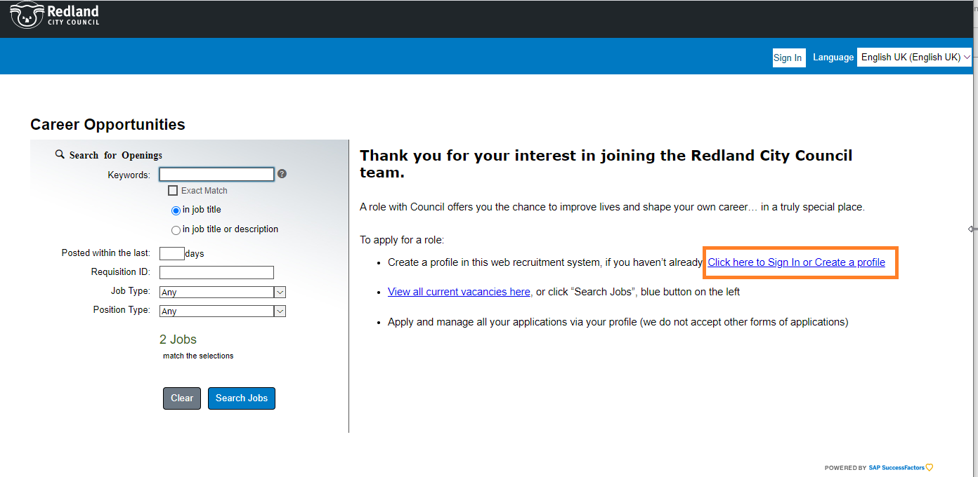
- Ensure that the language is “English UK” then select “Create an account”
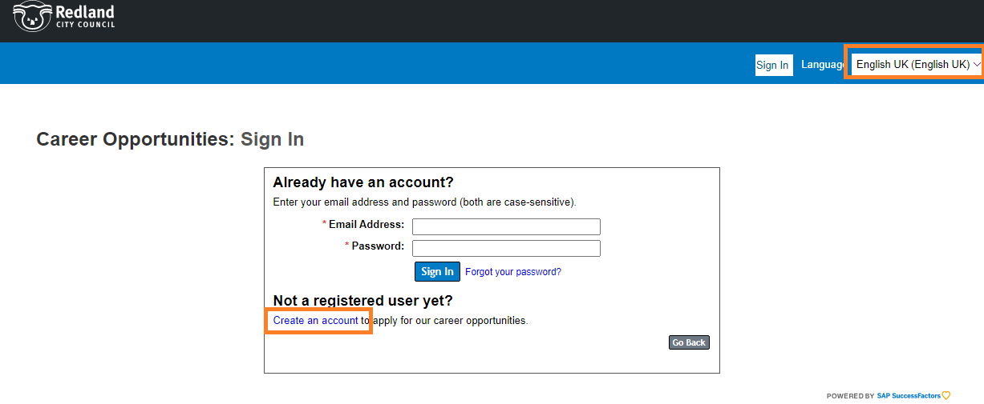

- Complete all fields, and select the “Read and accept the data privacy statement” link
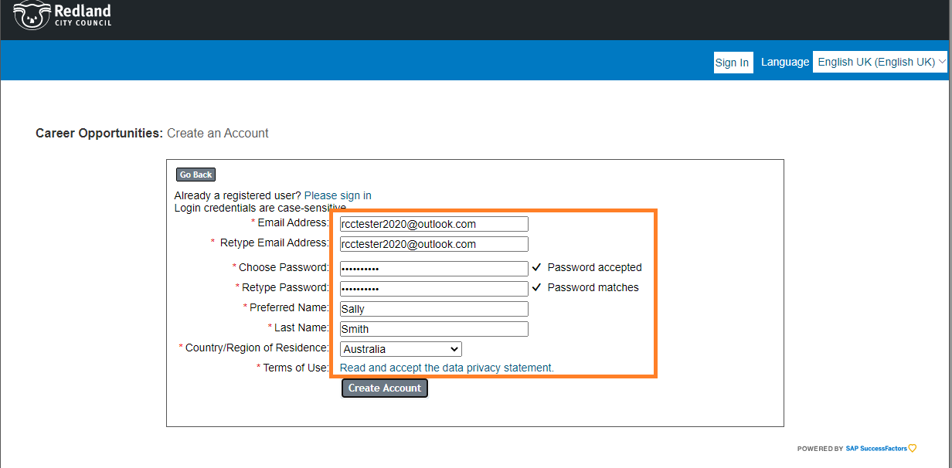
- Read, and if you accept the Data Privacy Consent Statement, press “Accept”
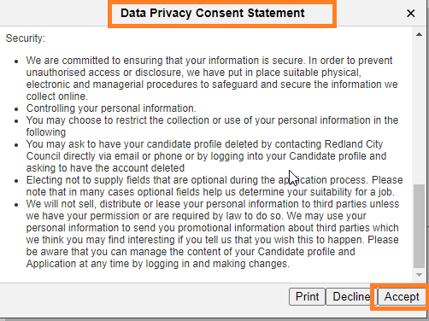
- When returned to this screen, check all information looks correct and select “Create Account”
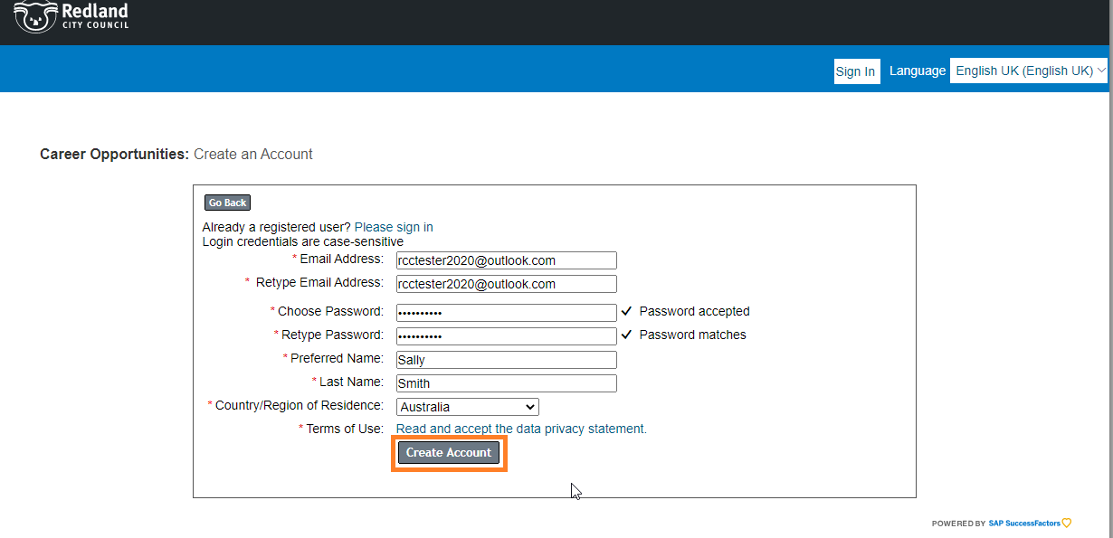
- You will receive a message advising that an email has been sent with a Passcode.
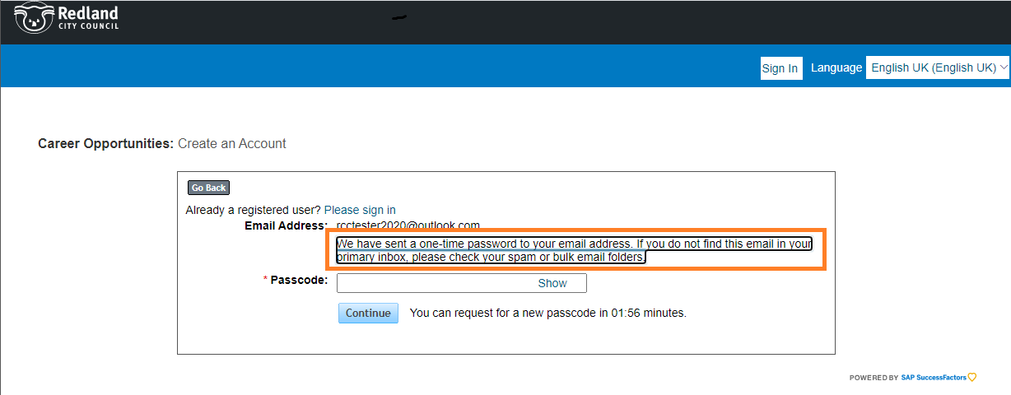
- Open your email to obtain the Passcode. You may need to check your Junk mail.
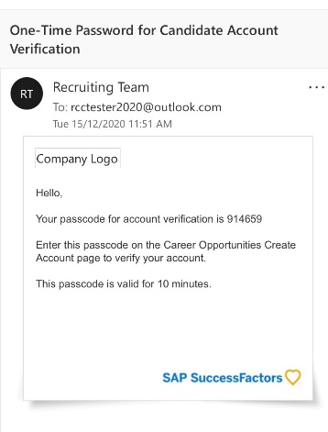

- Enter the Passcode and select “Continue”.
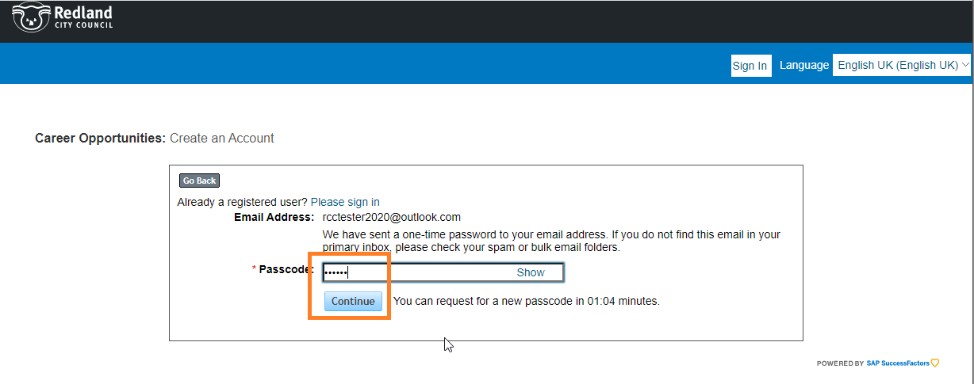
- You are now signed in.

Searching for and Applying for Jobs

- Select the “Search Jobs” link
- To view the details relating to a job, click the Job Title.
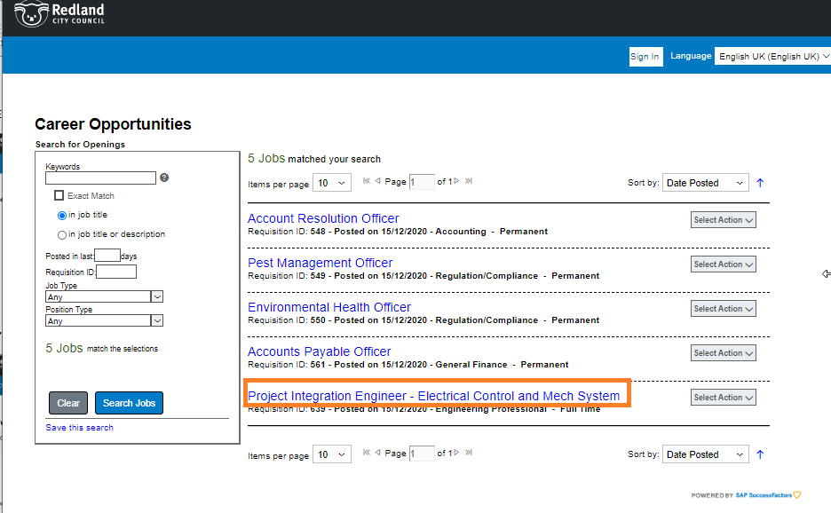

- All details relating to the job and what Council requires in an applicant are displayed. Please read the Position Description and information regarding the type of application you are required to submit. Contact details are provided should you require further information relating to the job.
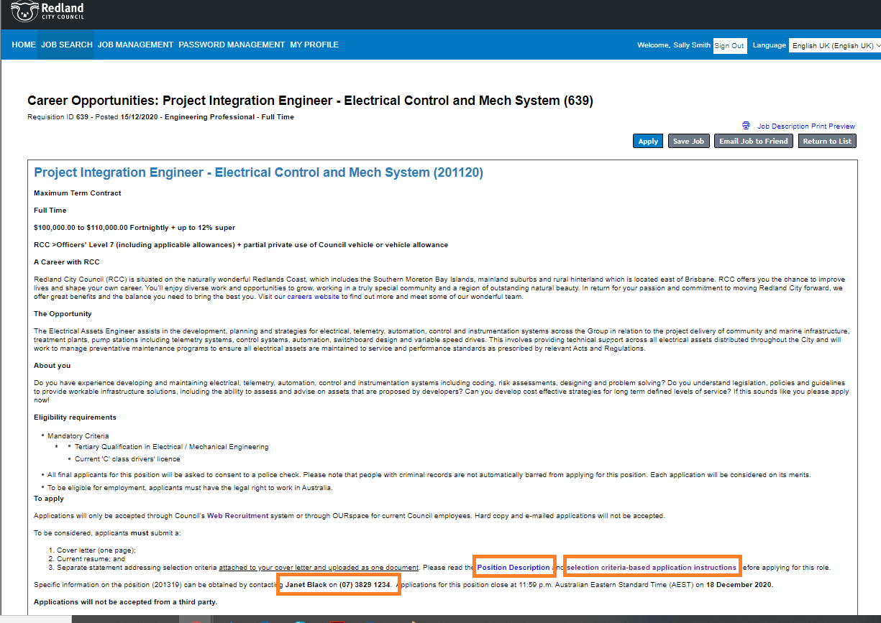

- Select “Apply” (you can start an application and save it to complete at a later date during this step).
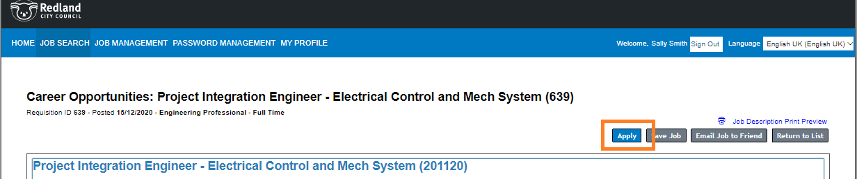

- You will be prompted to upload your Resume at this stage. Note: once your application has been submitted, you are unable to amend your resume. Refer to section 7 below for further details.
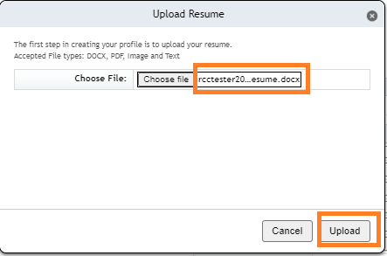
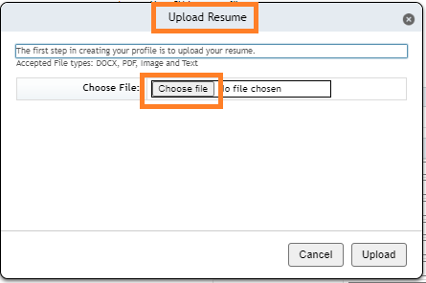

- Complete all fields, noting that mandatory fields are marked with an *
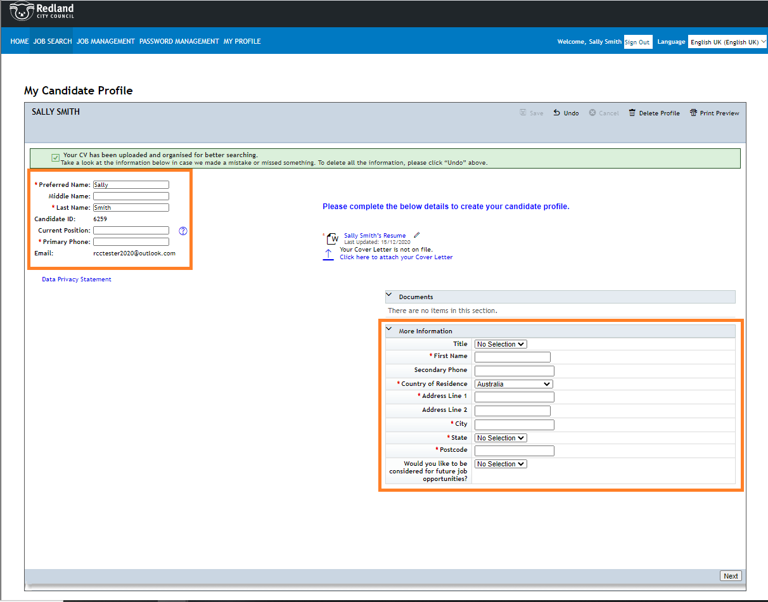

- Check that all details look correct then select “Save” and then “Next”
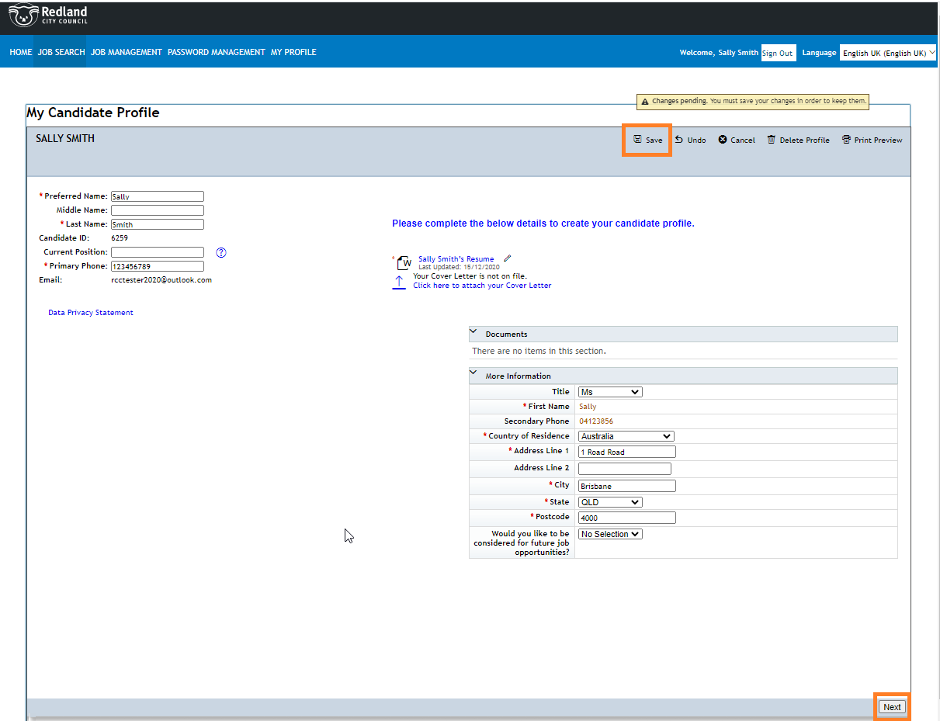

- Upload your Cover Letter for the job you are applying for at this step

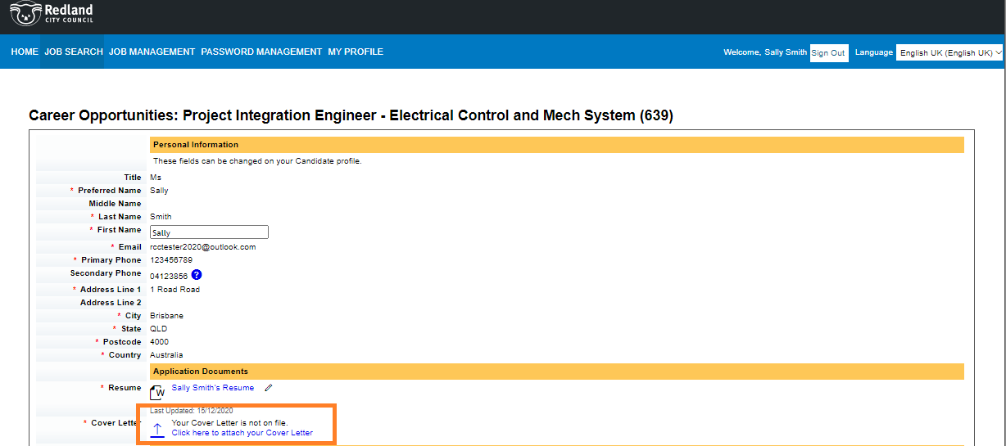

- Complete all fields then select “Apply”. If you are not ready to submit your application yet, you can select “Save” and complete it at a later date (see Section 3).
Note: Some job applications will require you to answer some Questions at this step (not all).
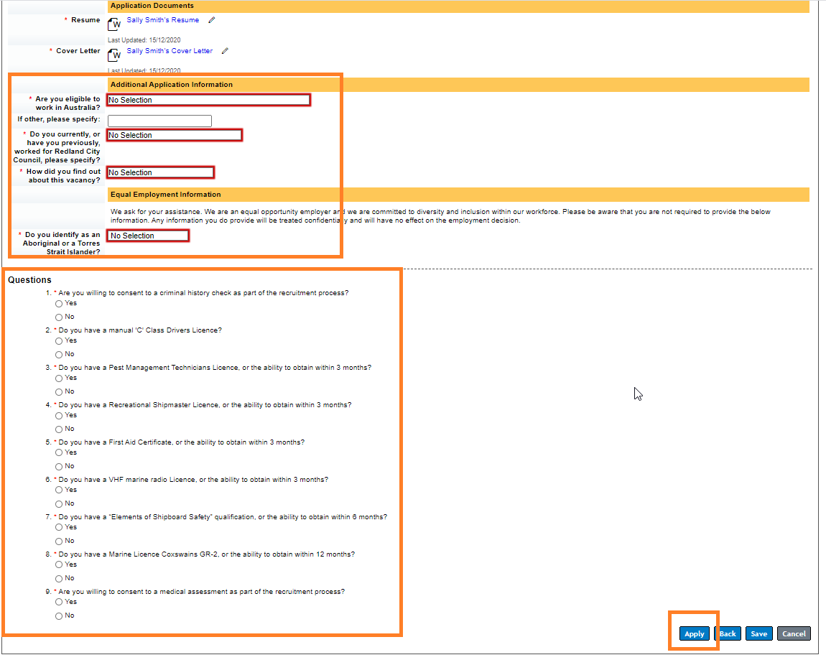

- Your application has been submitted and you will receive an email to confirm this. You may need to check your junk mail if you do not receive a confirmation.
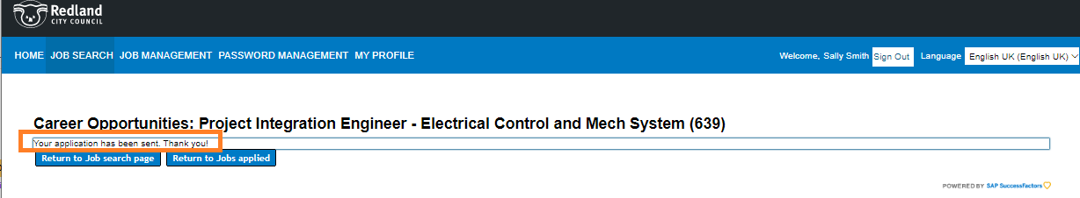

- You will see your Job Application under “Job Management”, “Other Applications”
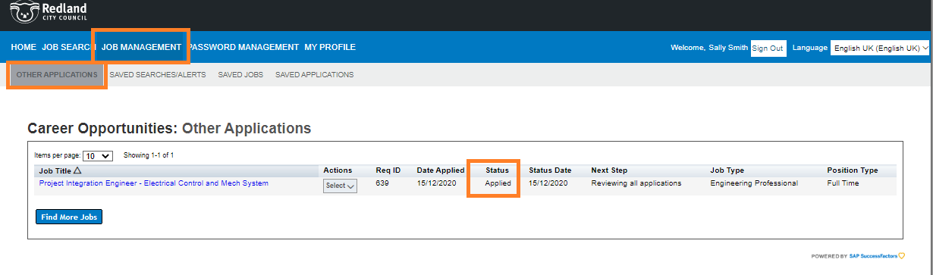

Saving your application in draft and submitting later

- Select “Apply” within the job details screen.
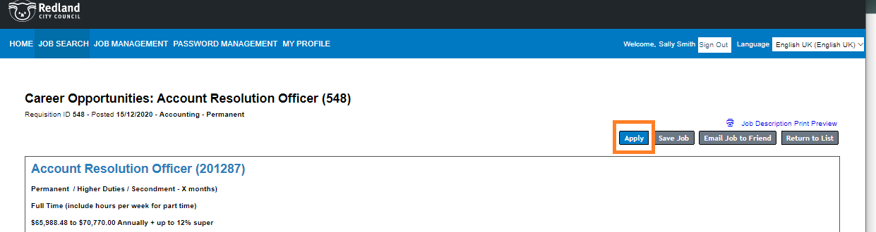
- Select “Next”
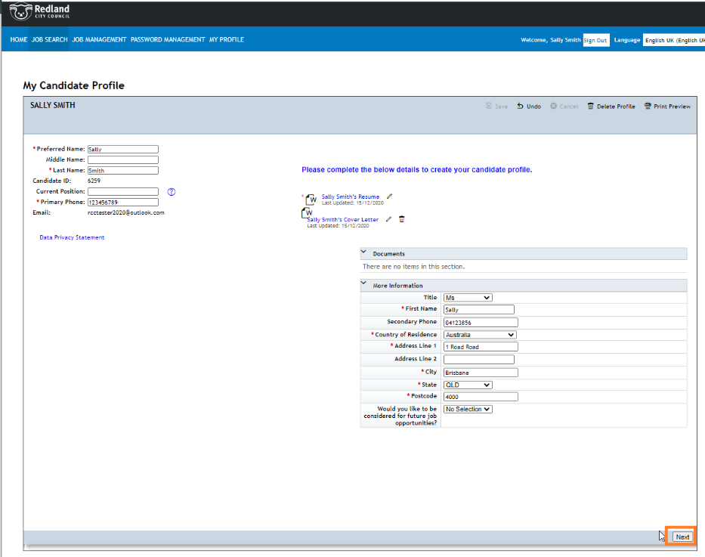
- Complete as many field as you wish then select “Save”
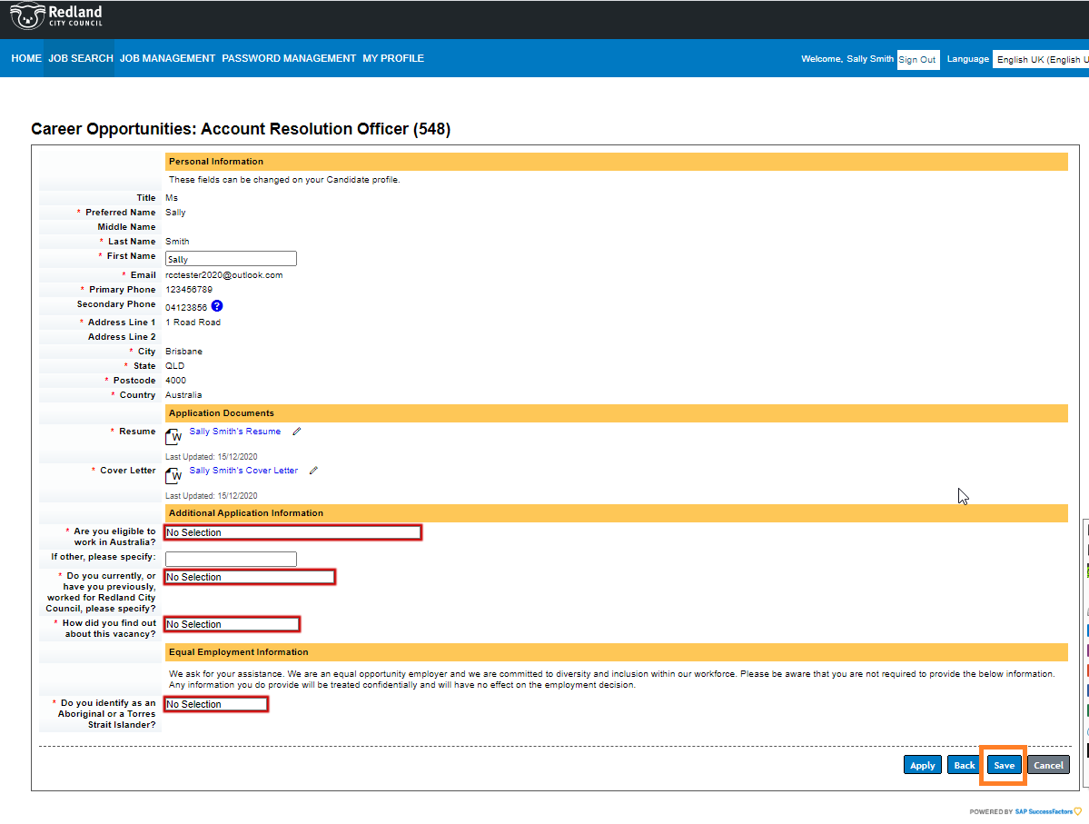
- A draft application will be saved
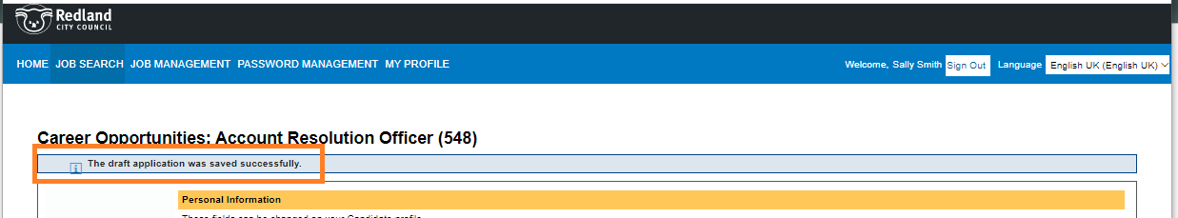

- View your saved application under “Job Management”, “Saved Applications”. This is where you will continue your application at a later date.
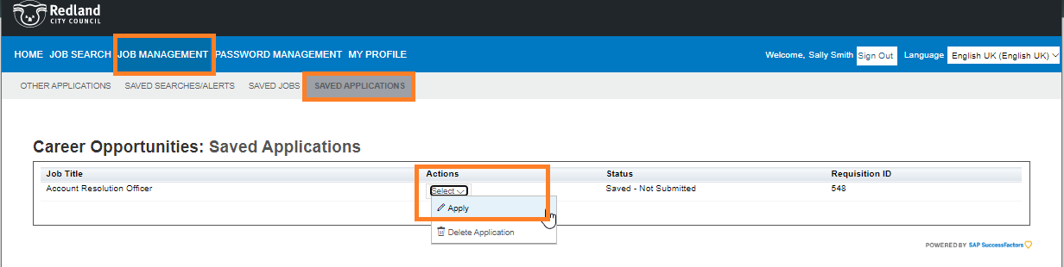
- When Applying from your Saved Applications, your Profile page will appear.
Note: If you have applied for a role previously, you latest Cover Letter will be attached to your profile and will not be relevant for the new application. In this case, delete your Cover Letter, as you will upload a relevant cover letter in the Job Application screen (next step) then select “Next”
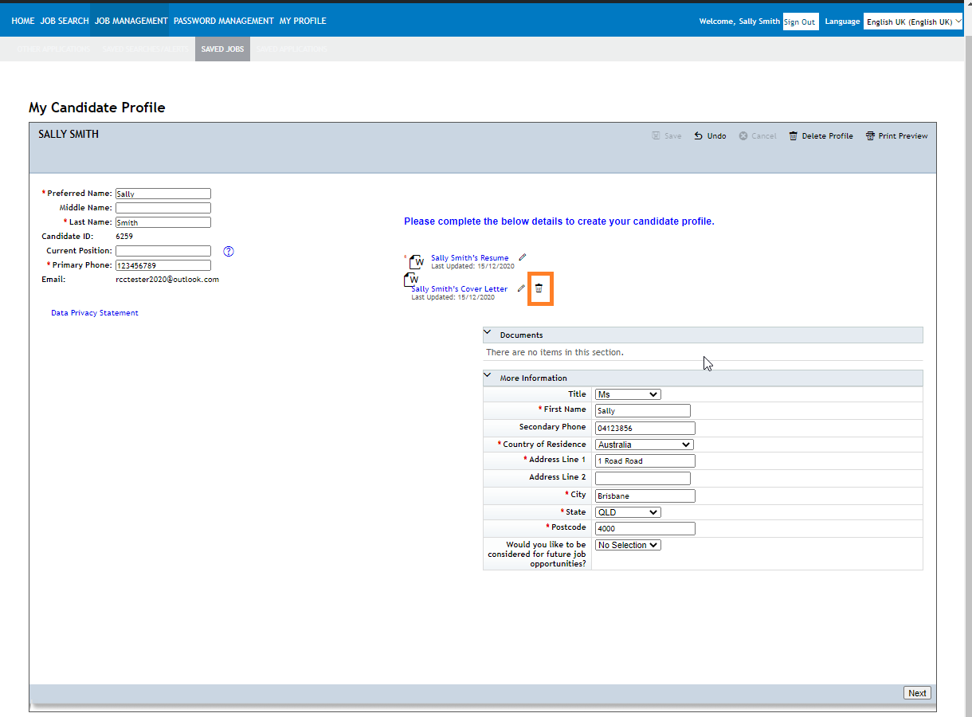

- Upload the Cover Letter related to this job application.

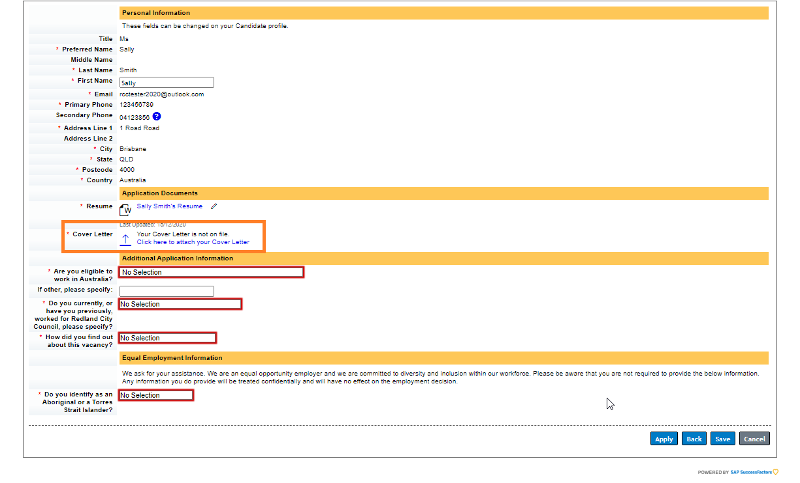
- Complete all fields then select “Apply”.
Note: Some job applications will require you to answer some Questions at this step (not all).
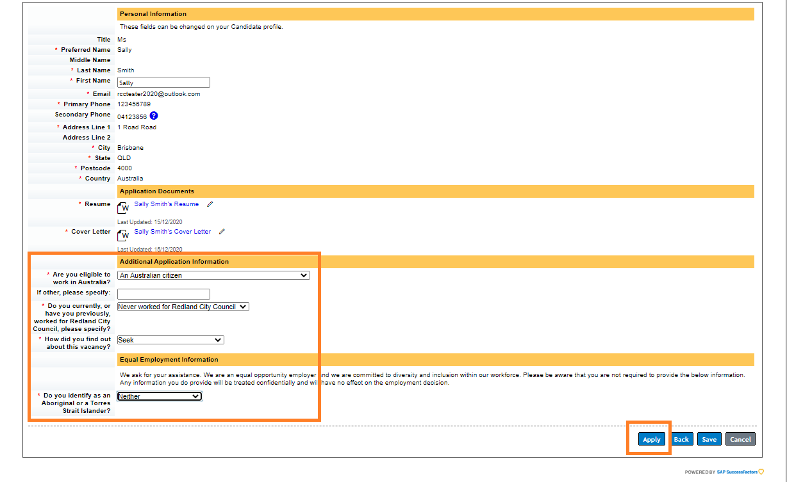

Withdrawing an application
If you have decided that you no longer wish to be considered for a job which you have applied for, please Withdraw your application.
Note: if the job advertisement has already closed, please ALSO email recruitment@redland.qld.gov.au to advise of your withdrawal.
- Within “Job Management”, “Other Applications” locate the relevant application and under “Actions”, “Withdraw Application”
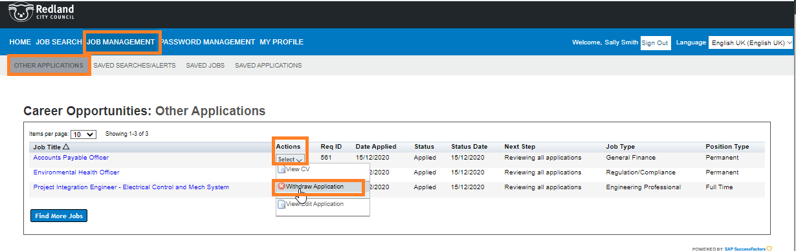
- Confirm your withdrawal.
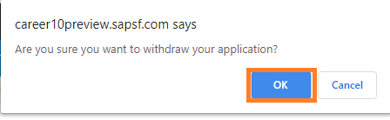
- The status will be updated to reflect the withdrawal.
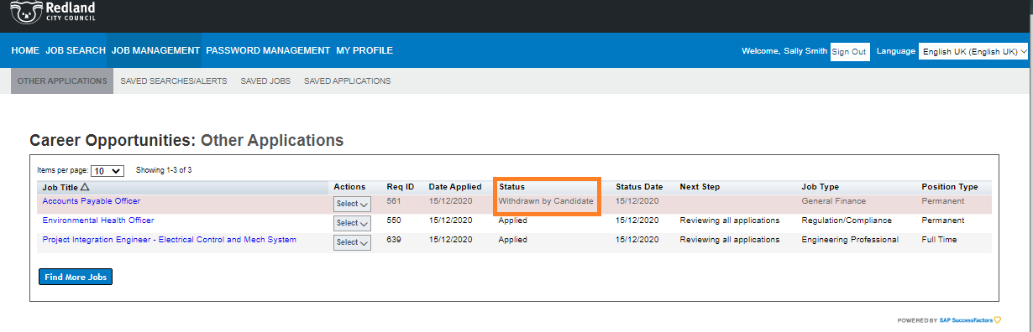
Note: if the job advertisement has already closed, please ALSO email recruitment@redland.qld.gov.au to advise of your withdrawal.

Create a Job Alert
By creating a Job Alert, you will receive an email advising when new jobs have been advertised. You can choose the frequency of these job alerts to be Daily; Weekly or Every Two Weeks.
- Within “Job Management”, “Saved Search/Alerts” select “Create New Job Alert”
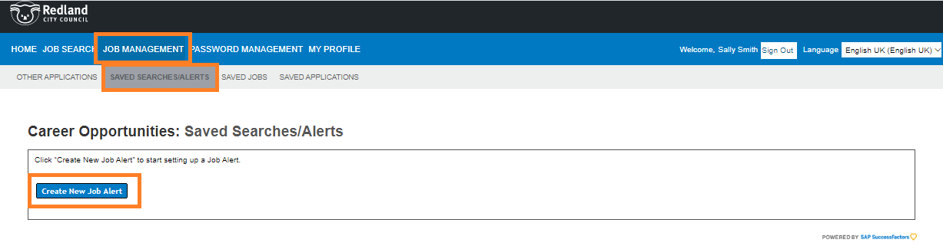
- Update all mandatory fields (*) and Save your preferences.
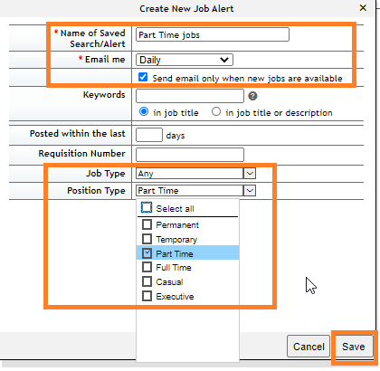
- Your Job Alert is now saved. You can edit this at any time.

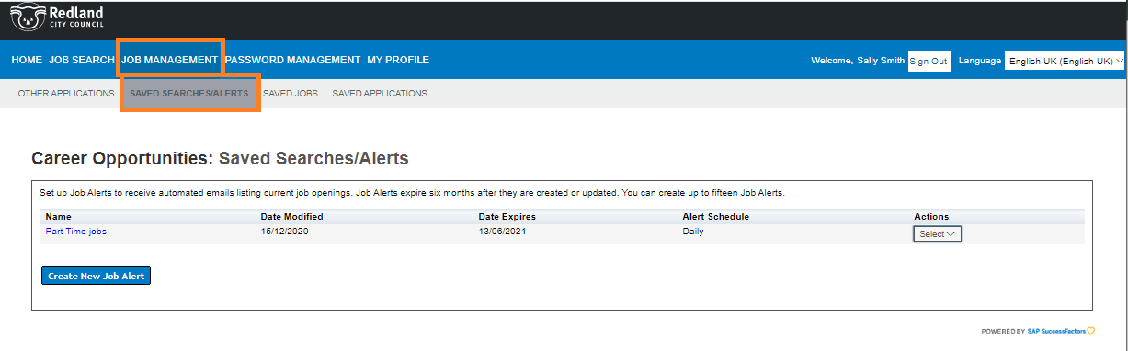

Resetting your password
- Navigate to the “Sign in” page and select “Forgot your password?”
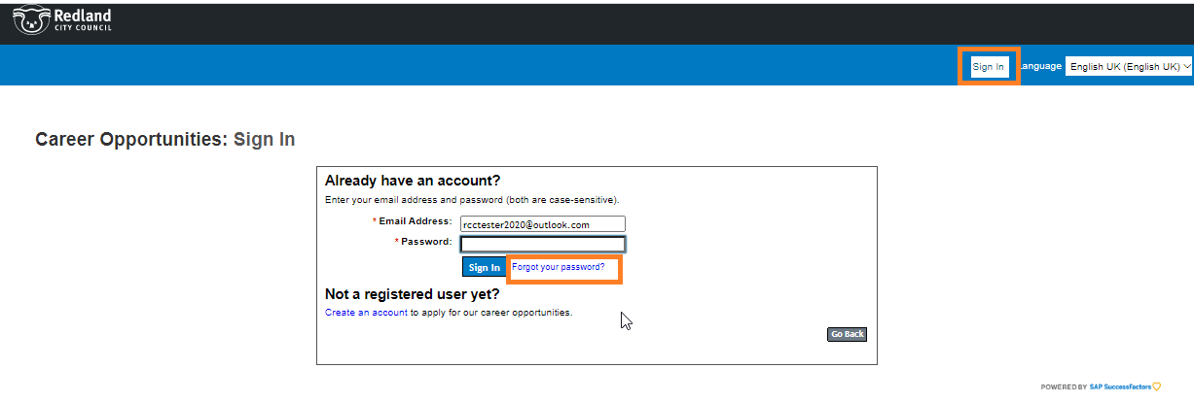
- You will be required to input your log-in email address. Then select “Submit”
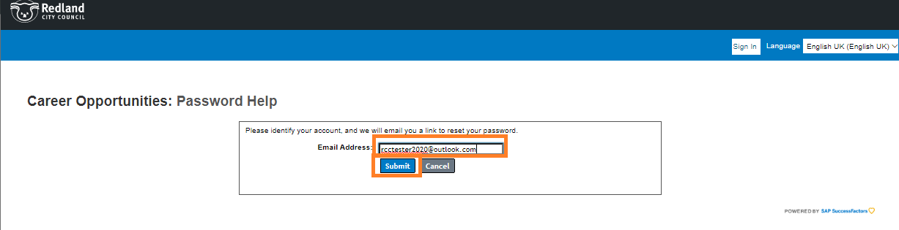

- An email will be sent. You may need to check your Junk mail
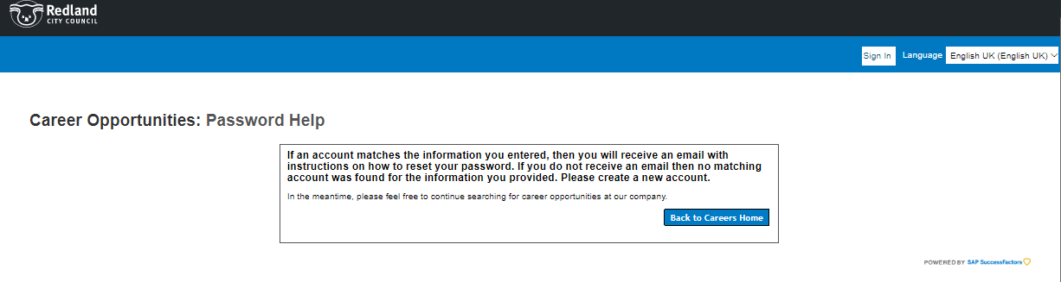
- Click on the link within the email to reset your password.
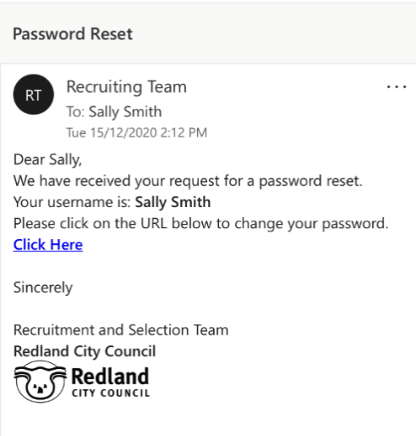
- Update your password.
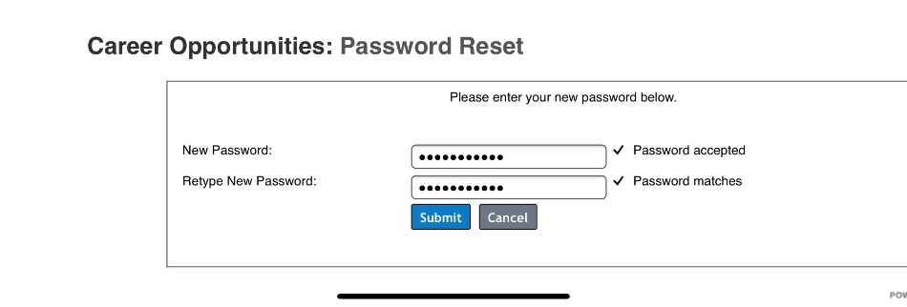

- Your password is now reset and you can continue with your “Sign in”
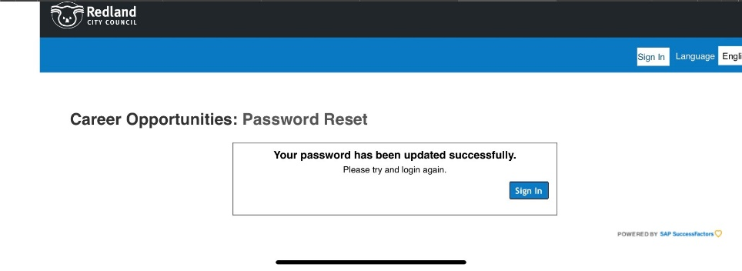

Updating your Resume and/or Cover Letter for an application
Once you have submitted your application, you are unable to make a change to your Resume and Cover Letter. If you do need to amend either of these documents, you will need to Withdraw your application, resubmit your application and upload your updated documents.
Important information: you can ONLY make this change while the job is still being advertised. No changes can be made once the job advertisement has closed.
- Navigate to the “Other Applications” tab within your Candidate Profile and select “Withdraw Application”
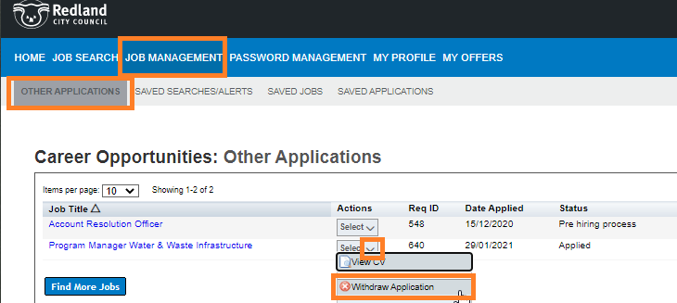
- Select “Resubmit Application”

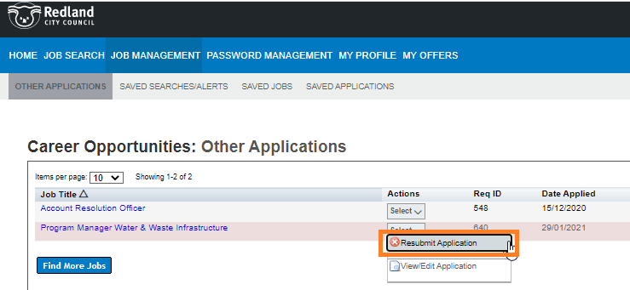

- Navigate to the Application Documents section within the application and edit the document/s you wish to update.
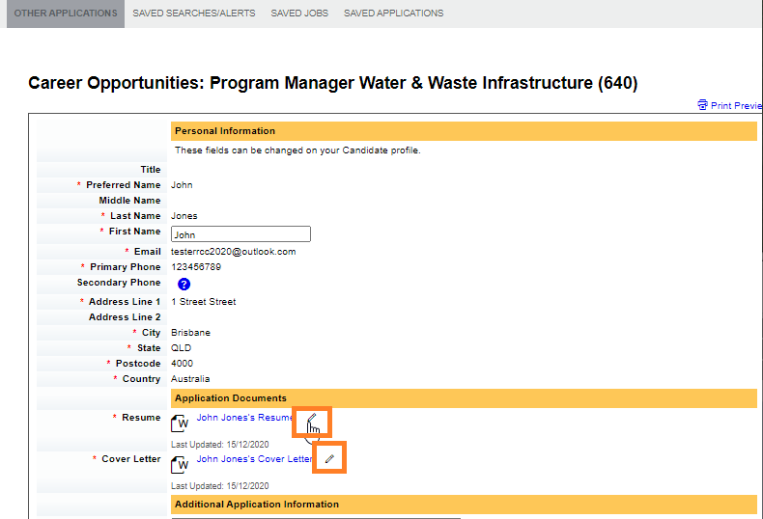
- Follow the prompts to upload your document/s
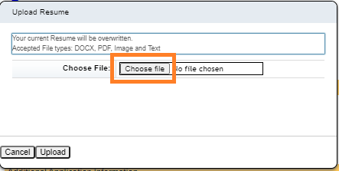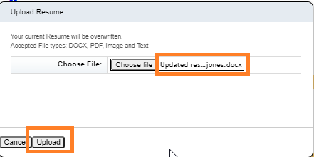

- Select “Update” at the bottom of the page.
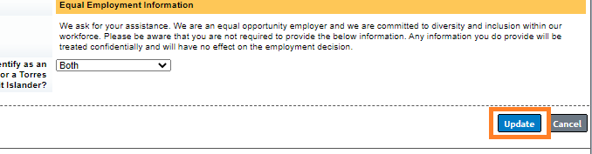

Receiving an Offer
- Successful applicants will receive an email advising that they have received a “Letter of Offer”. The email will ask you to sign into your Candidate Profile and when there, navigate to the MY OFFERS tab.
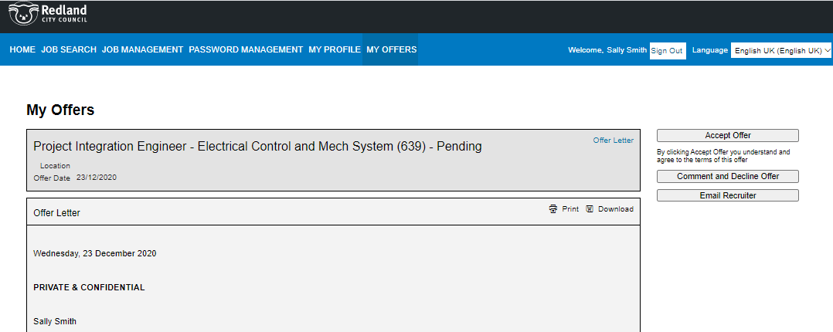

- If you wish to discuss the conditions of your Offer, please phone the Manager using the contact details contained in the Letter of Offer, or alternatively, email the Talent Engagement Team via email by selecting “Email Recruiter” or phone the Talent Engagement Team on 07 3829 8108.
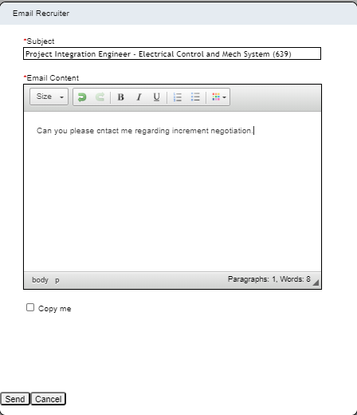

Accepting an Offer
- Once you have read and understood your Offer Letter, select “Accept Offer” in the MY OFFERS tab within your Candidate Portal.
Select download to obtain a PDF copy of your letter of offer

- Your accepted offer will now be in your Offer History. You can view a PDF copy of your offer at any time by selecting “View Offer”
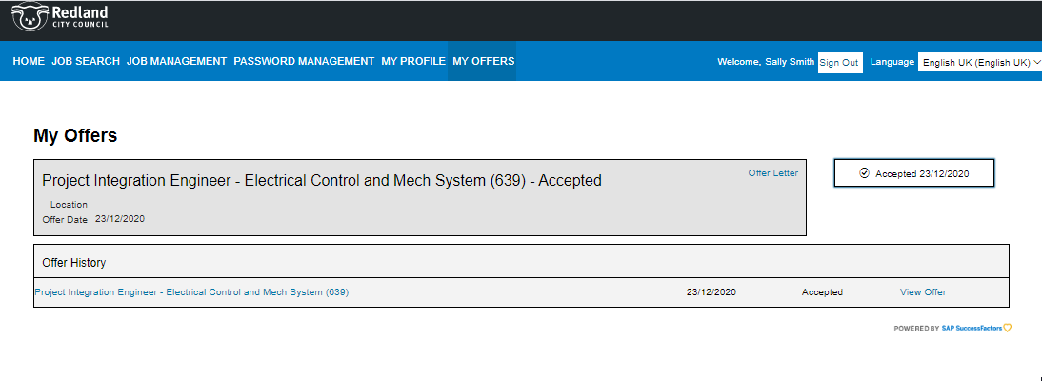
- You will receive an email within two days prompting you to complete the onboarding documentation. Note: your onboarding paperwork is contained within our separate on-line Onboarding system and as such, you will be requested to set up a separate password for that system. Please refer to our “Onboarding tips and Tricks” document for further information.

Declining an Offer

- If after speaking with the contact person identified within your Letter of Offer or one of our Talent Engagement Team members (either by phone on 07 3829 8108 or via email at recruitment@redland.qld.gov.au) you decide to decline the offer of employment, navigate to the MY OFFERS tab within your candidate profile and select “Comment and Decline Offer”.
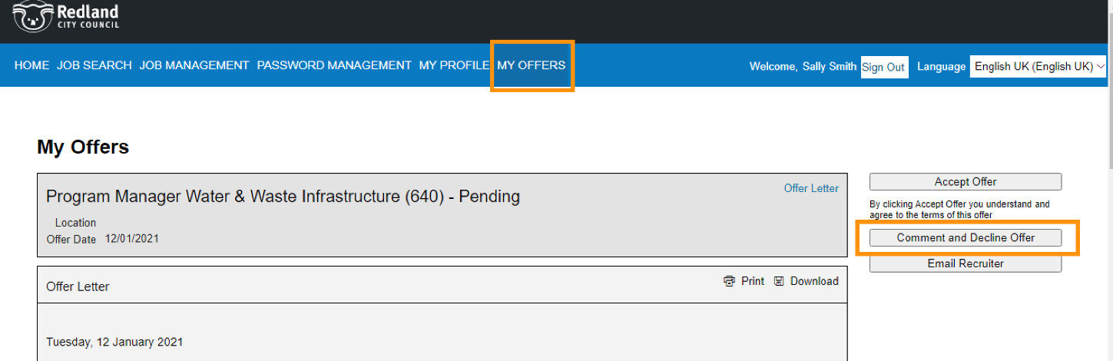

- Input comments which will be a confirmation of your discussions with the contact person identified within your letter of offer or Talent Engagement Team the select “Decline Offer”

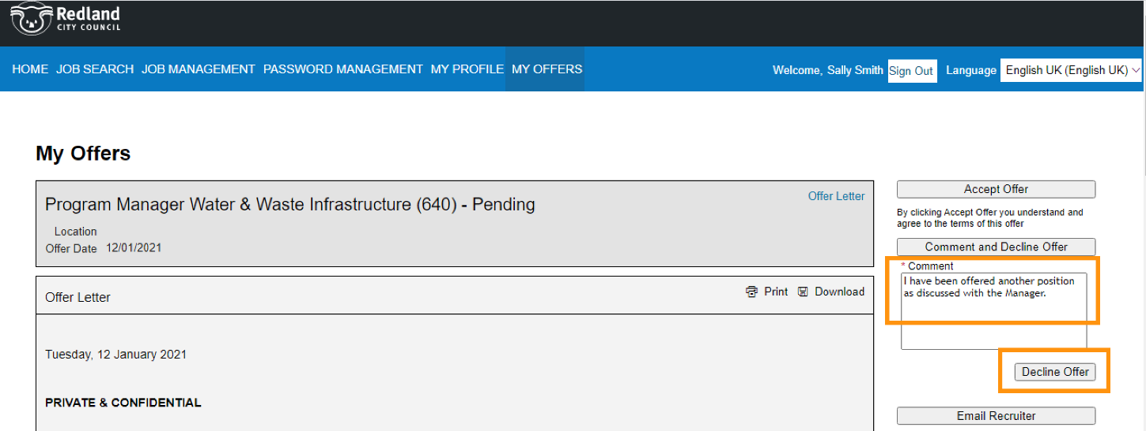

- The Declined Offer will appear in your “Offer History”.
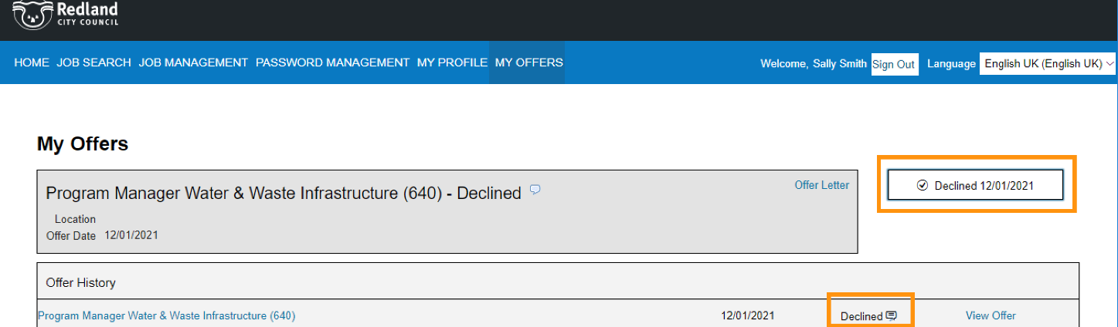

Clearing Cache & Cookies

Cookies are files created by sites you visit to make your online experience easier and the cache remembers parts of pages, like images, to help them open faster during your next visit, however sometimes these can interfere with processes you are trying to complete in the Recruitment Portal.
Below are some helpful links on how to clear cache & cookies in commonly used browsers
- Chrome
- Internet Explorer
- Safari on Mac
- Firefox

