<INSERT YOUR EVENT NAME HERE>
Temporary Event Management Plan
(Intended for events with over 500 people)

How to best use this template - Before completing this template, ensure you have read through the Redland City Council Event Portal and Event Information Kit. These tools will provide assistance for how to complete the sections of this Event Management Plan template. Each section is to be completed with information specific to your event. Additional information can be added in each section and table (by inserting extra rows).

Please be advised - This template is provided by Redland City Council as an information source only. Redland City Council makes no statement, representation or warranty about the quality, accuracy, context, completeness, availability or suitability for purpose of the templates and to the maximum extent permitted by law, disclaims all responsibility and liability for all expenses, losses, damages and costs that might be incurred by you or any other person as a result of the use of the template. Information contained within the template is suggestive only. Reproduction and use of the template is at your own risk.

Links to other relevant documents/tools:
Event Planning Tools
Event Information Kit

Table of Contents
1.0 INTRODUCTION 3
1.1 Event Details 3
1.2 Event Description 3
1.3 Event Organiser’s Details 3
1.4 Event Program 3
2.0 EVENT REQUIREMENTS 4
2.1 Site Plan 4
2.2 Risk Assessment 4
2.3 Public Liability 4
2.4 Staff and Key Contacts 4
2.5 Traffic Management Plan (if applicable) 5
2.6 Community Event Notice 5
3.0 PUBLIC HEALTH 5
3.1 Food Vendors 5
3.2 Alcohol 6
3.3 Toilet Facilities 6
3.4 Cleaning and Sanitising 6
3.5 Water Supply 7
3.6 Waste Management 7
3.7 Environmental Impact and Nuisances 7
4.0 SAFETY 7
4.1 First Aid 7
4.2 Incident Reporting 8
4.3 Signage (inside the event) 8
4.4 Power Supply 9
4.5 Lighting (if applicable) 9
4.6 Temporary Structures (if applicable) 9
4.7 Amusement Operators (if applicable) 9
4.9 Fireworks (if applicable) 10
Appendix 1 – Risk Calculator 11
Appendix 2 – Risk Assessment Template 12
Appendix 3 – Incident Reporting Log 13

1.0 INTRODUCTION

1.1 Event Details
Event Name
Type of Event | e.g. Cultural Festival/Music/Markets etc
Date/s
Location
Number of Event Attendees for duration of event
Is the Event Ticketed | ☐ Yes ☐ No

1.2 Event Description
Event Description
(e.g. type of event, target audience, event highlights and entertainment)

1.3 Event Organiser’s Details
Event Organiser (individual or organisation)
Contact Person
Contact Phone Number
Email Address
Postal Address

1.4 Event Program
Include the bump in/out dates and times for the venue and any major events/activities during the event.
Date/Time | Activity
e.g.  01/01/2021  6.00am  8.00am | Bump In  Staff arrive on site  Contractor arriving for XXX
 | Insert additional rows in table as needed

2.0 EVENT REQUIREMENTS

2.1 Site Plan
Attach your event site plan to this document. Refer to this link for a site map example.
Site plan attached | ☐ Yes ☐ No

Ensure the event site plan includes:

☐ Location of venue (e.g. google maps image)
☐ Surrounding roads
☐ Venue/Event boundary
☐ Car parking
☐ Emergency vehicle access
☐ Emergency exits
☐ Evacuation routes
☐ Emergency assembly areas
☐ Firefighting equipment
☐ Pedestrian walkways
☐ First aid location/s
☐ Stall locations
☐ Amusement operators
☐ Stage/temporary structures
☐ Amenities including toilets, hand washing stations, rubbish/recycling bins

2.2 Risk Assessment
Attach your completed Risk Assessment to this document. A Risk Assessment must be completed prior to the event and should identify, assess and control all risks relevant to the event.
All risks have been identified | ☐ Yes ☐ No
Risk assessment attached | ☐ Yes ☐ No
Refer to Appendix 1 for Risk Assessment Calculator and Appendix 2 for Risk Assessment Template.

2.3 Public Liability
Attach a copy of your Public Liability Insurance Certificate with this document. Public liability insurance must include; Insurer details, date of cover, amount of cover (no less than $20 million), and Redland City Council to be an interested party.
Public Liability attached | ☐ Yes ☐ No

2.4 Staff and Key Contacts
Number of staff at event
Number of volunteers at event

Provide a list of key contacts including names, roles/responsibilities, email and phone numbers of event team members, contractors and stakeholders.

Name/Organisation | Role/Responsibility | Contact Details
e.g. Jim Smith | Event Organiser | 04XX XXX XXX  jmith@thisevent.com
 | Site Manager
 | First Aid
 | Traffic Controller
 | Security
 | Electrician
 |  | Insert additional rows in table as needed

2.5 Traffic Management Plan (if applicable)
Attach Traffic Management Plan and any relevant Traffic Control Permits (if applicable) to this document if this is required for your event. Refer to the Event Information Kit for more information.
Traffic Management Plan attached | ☐ Yes ☐ No ☐ N/A

2.6 Community Event Notice
Council recommends you notify the community of the event in advance. This may be in form of a letterbox drop or signage etc. You can utilise Council’s template to develop your own Community Event Notice.
How will you advise the community?
(i.e. letterbox drop, social media posts etc)
When will you notify the community?
Additional details/comments

3.0 PUBLIC HEALTH

3.1 Food Vendors
Provide a list of food vendors (both temporary food stalls, mobile food vehicles, caterers etc). You will also be required to check each food vendor holds a current Food Business Licence and ensure a copy of their current certificate is provided to Council prior to the event (certificate must also be displayed at each stall).
Business Trading Name | Contact Number | Type of licence (i.e. temporary food stall, mobile food vehicle etc)
e.g. The Potato Van | 04XX XXX XXX | Mobile Food Van
 |  | Insert additional rows in table as needed

3.2 Alcohol
Provide information relating to alcohol being sold/served at the event. You will need to provide a copy of your Liquor Licence (where applicable).
Will alcohol be at the event? | ☐ Yes ☐ No
Has the liquor licence been attached? | ☐ Yes ☐ No ☐ N/A
Additional details/comments

3.3 Toilet Facilities
Provide details on the number of toilets that will be available or supplied at the event. Toilets must be provided with soap, running water and paper towels. Refer to the Event Information Kit for a guide on how many are required for the event.
Amenity Type | Number of toilets
Male
Female
Disabled
All toilets provided with hand washing (including soap and paper towel)? | ☐ Yes ☐ No

3.4 Cleaning and Sanitising
Provide details on how the facilities and event grounds will be cleaned and serviced during/after the event.
Will a cleaning roster/procedure be implemented for the event? | ☐ Yes ☐ No
Provide details (i.e. external cleaning contractor or event staff, cleaning and sanitising methods and frequency).

3.5 Water Supply
Provide information on water supply will be made available at the event e.g. will there be an adequate supply of potable water for drinking?
Will there be potable (drinking) water be at the event? | ☐ Yes ☐ No
Provide details

3.6 Waste Management
Provide information on the number of general waste and recycling bins that will be at the event. Provide the waste contractor’s details and how waste will be handled/disposed of during and after the event. Refer to the Event Information Kit for recommended number of bins to be provided.
Waste contractor/s
details
No. General waste bins |  | No. Recycle bins |  | No. Skip bins

3.7 Environmental Impact and Nuisances
While conducting the event you must take all reasonable and practical measures to minimise environmental impacts and nuisances to the surrounding community. Provide information on the activities that are likely to cause a nuisance during the event (such as noise from music) or an environmental impact (such as spills or waste that require clean up) and address how these will be monitored, minimised or controlled.
Type of impact | Likely to occur | Details
Noise (i.e. music, PA announcer etc) | ☐ Yes ☐ No
Obtrusive lighting | ☐ Yes ☐ No
Dust/fumes/smoke | ☐ Yes ☐ No
Liquid spills or waste requiring clean up | ☐ Yes ☐ No
 |  | Insert additional rows in table as needed

4.0 SAFETY

4.1 First Aid
Provide details of the first aid provisions that will be available at the event. Include information on the number of first aid personnel, first aid posts and qualifications. Refer to the Event Information Kit for recommended numbers per attendees.
Number of first aid stations
Details of first aid officer/s (include company and individual name) |  | Are they qualified?
 |  | ☐ Yes ☐ No
Insert additional rows in table as needed |  | ☐ Yes ☐ No

4.2 Incident Reporting
During the event it is important to make a record of incidents and near misses that occur. These should be logged in a format that includes; date & time of incident, description of what occurred, person involved and action taken.
Will incidents and near misses be reported? | ☐ Yes ☐ No
Provide details on how these will be reported (i.e. what method will be used for reporting).
An incident reporting log template has been provided in Appendix 3.

4.3 Signage (inside the event)
Ensure applicable signage is displayed inside the event for safety and communication to attendees. Provide information on signage that will be installed.
Signage | Provided | Details
Entry/Exit | ☐ Yes ☐ No
Information Point | ☐ Yes ☐ No
No Smoking / Smoking Areas | ☐ Yes ☐ No
Alcohol Consumption Area/s | ☐ Yes ☐ No
Alcohol Consumption Rules | ☐ Yes ☐ No
First Aid Location/s | ☐ Yes ☐ No
Toilets | ☐ Yes ☐ No
Drinking Water | ☐ Yes ☐ No
 |  | Insert additional rows in table as needed

4.4 Power Supply
Provide a description of the power supply for the event. Information should include if the supply is from a generator or another source. Refer to the Event Information Kit for electrical safety information and additional connection fees that may be required.
Will power be needed at the event? | ☐ Yes ☐ No
Detail how this will be supplied (i.e. power from venue or generator, will a licensed electrician be conducting the work).

4.5 Lighting (if applicable)
Provide information on the lighting that will be provided at the event. If your event is in the evening, consider lighting that may be necessary to ensure safety of attendees at the event and also entering/exiting the event.
Will sufficient lighting be at the event to ensure safety? | ☐ Yes ☐ No ☐ N/A
Detail the type of lighting that will be installed (ensure this is included on your site map also).

4.6 Temporary Structures (if applicable)
Provide information on any temporary structures that will be erected at the event. Refer to the Event Information Kit for types of structures that require a Building Permit.
Type of structure | Certificate attached or can be provided at a later date
 | ☐ Yes ☐ TBA
 | ☐ Yes ☐ TBA
Insert additional rows in table as needed | ☐ Yes ☐ TBA

4.7 Amusement Operators (if applicable)
List all amusement ride operators and provide a copy of their Certificate of Registerable Plant (insert more rows as needed).
Operator Name | Type of activity | Certificate attached
 |  | ☐ Yes ☐ No
 |  | ☐ Yes ☐ No
 | Insert additional rows in table as needed | ☐ Yes ☐ No

4.9 Fireworks (if applicable)
Attach relevant contractor’s licence and their public liability if a fireworks display is proposed for the event. Refer to the Redland City Council Event Information Kit for details of what is required.
Contractor’s Licence & Public Liability attached | ☐ Yes ☐ No ☐ N/A

Appendix 1 – Risk Calculator
See this link for an online copy of the Risk Calculator.
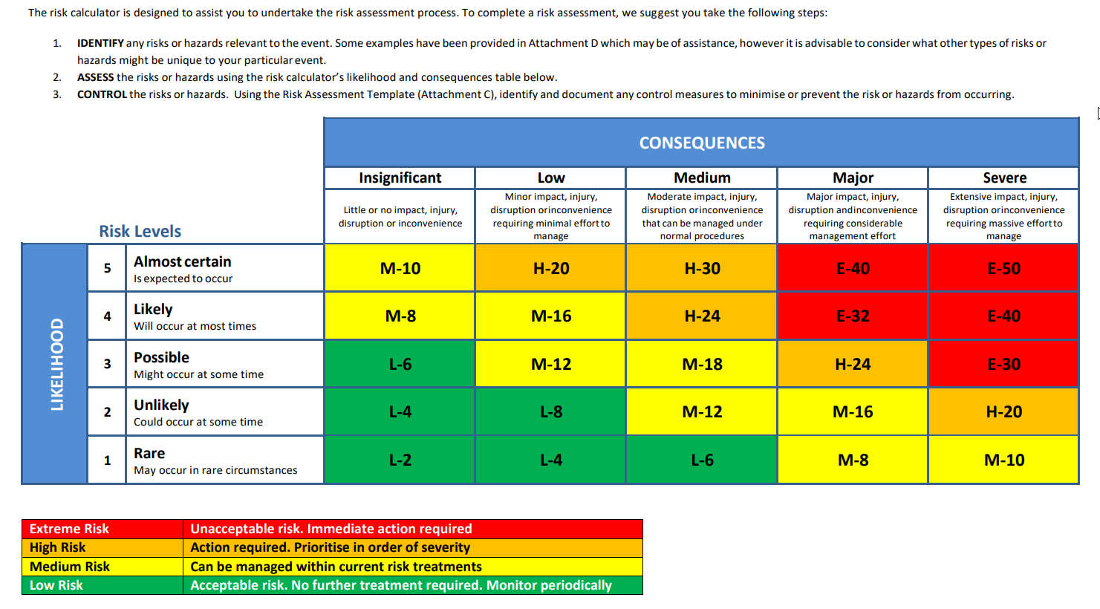

Appendix 2 – Risk Assessment Template
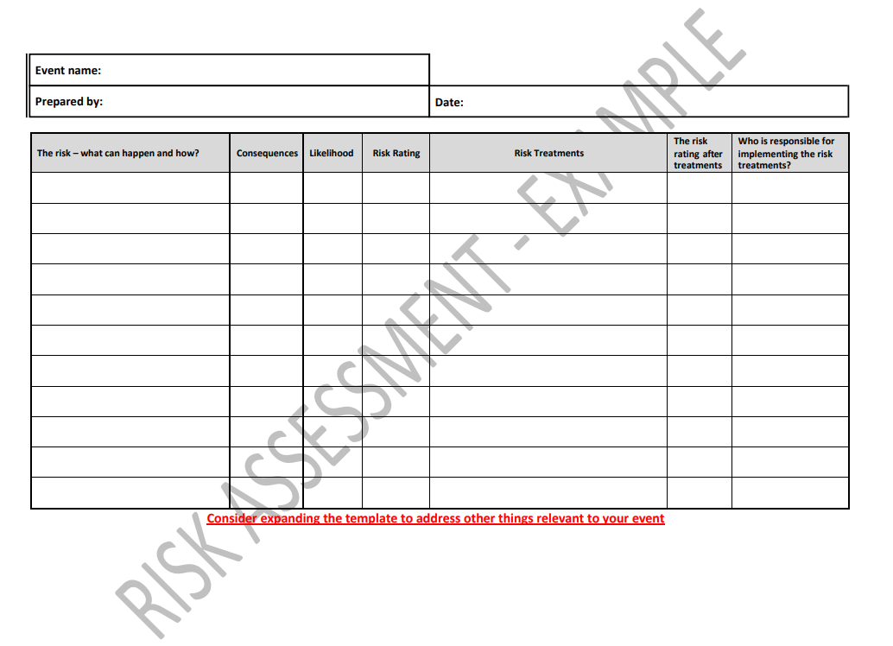
See this link for an online copy of the Risk Assessment Template you can edit. You can also see a completed Sample Risk Assessment here.

Appendix 3 – Incident Reporting Log
Date/Time of Incident | What occurred? | Person/s involved | Action taken
e.g. 1/04/2022 9.45am | Child scraped their knee on fencing around animal enclosure.  Event manager was made aware of the issue after child presented to the First Aid tent. | Johnny Smith (child)  John Smith (parent)  Peter Brown (first aid officer)  Sally White (event site manager) | Site manager inspected the fencing at the animal enclosure. Sharp section of fence was removed. Child was treated by first aid officer. Child and parent details and incident have been recorded.

