Contractor: How to complete a Work Order – Mobility

Summary

This Quick Reference Guide explains how to complete a Work Order (WO) on a mobile device, including phones and tablets.

Reference Documents

Knowledge Base – WI-603 Execute a Work Order (Mobility)

What is a Work Order?

A Work Order is assigned work on a Redland City Council (RCC) asset.

Steps

- Select a Work Order to complete

Once the WO has been assigned, the contractor will receive a notification on their mobile device for ‘Newly Assigned Work’. Select DISMISS or the X to close the notification.

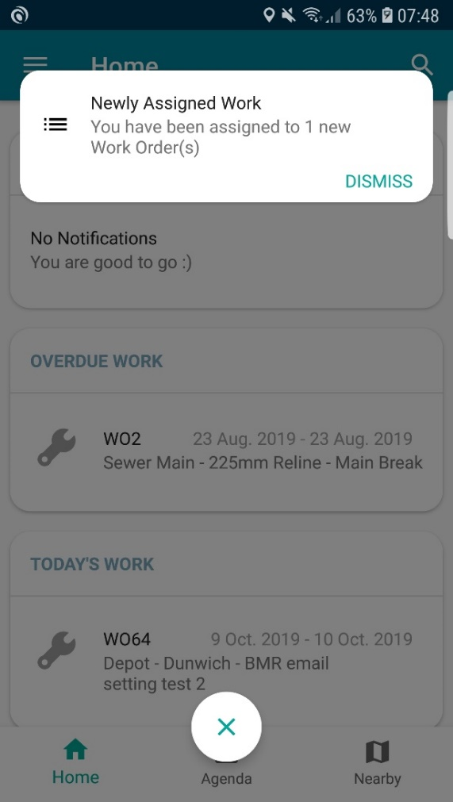

The app main screen will show visibility of:
- Alerts – notifications of incoming work
- Today’s Schedule – Overdue, Today’s and Nearby WOs
- The bottom tabs display different views of the work – Agenda (calendar) and Nearby (map)

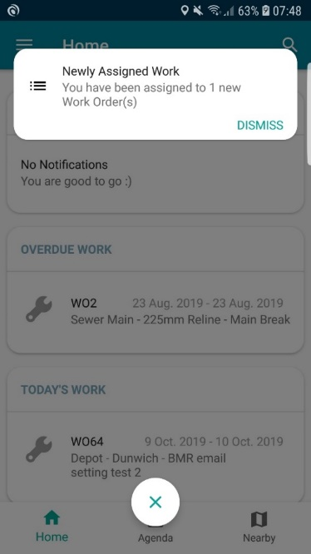
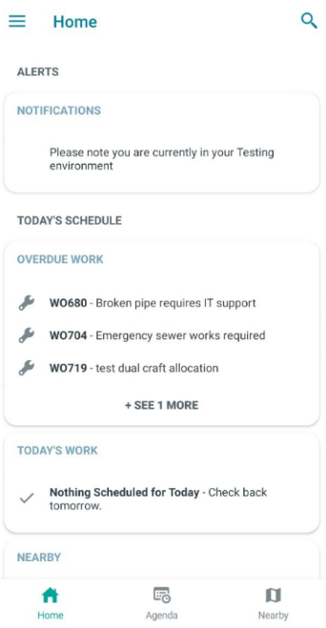

Open the WO to be completed by tapping on the WO.

Once open, the WO has five separate ‘tabs’ at the bottom of the screen. To access them, use the icons at the bottom of the screen.

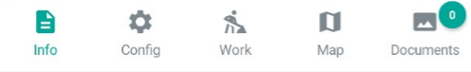

- Information Tab (Preview WO details) 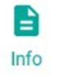

- Selected Asset – select the asset name to see more core details about the asset
- Information – is the WO brief description and will display the P&R sub-category (RCCs customer request system) if the WO has resulted from a customer request
- Priority (including Scheduled Start and Finish) – displays the WO priority and key dates for start and finish
- Comments – will display the P&R customer request full details if the WO has resulted from a customer request and any additional comments that may have been added. Add additional information by selecting Add
- Location – displays the defect point location for the WO. Use the four arrow buttons to expand to full map view

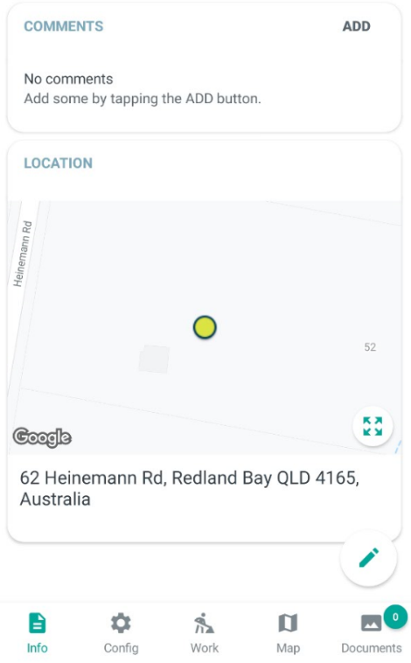
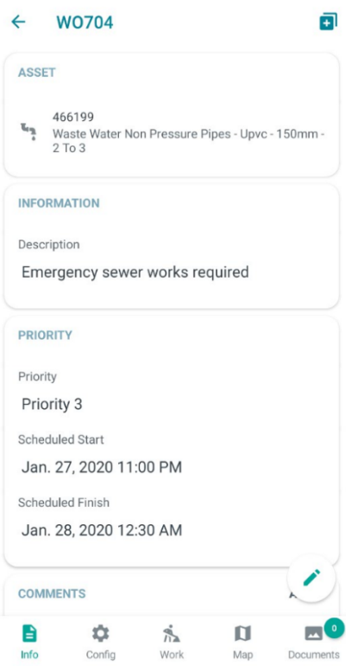

- Documents Tab 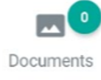

The documents tab – view and add photos to the WO. (Before work has commenced)

- Select the camera button to add a photo
- Take a photo and select OK to add it or RETRY to take again
- Enter a Label (title) for the document – optional or just leave the date
- Group – Photo
- Category – Photo
- Sub-category – should be before as the photo is taken prior to any work being done
- Select Annotate to add circles or text to the photo (not available on Apple, but you can annotate outside the app and load from the gallery)
- Select Save

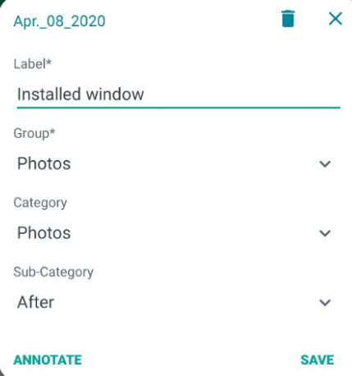
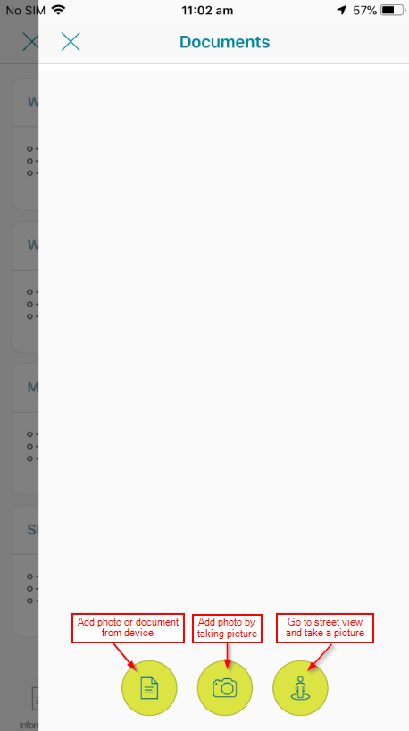

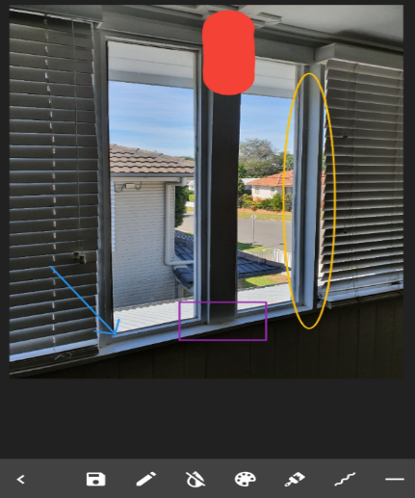

- Work Tab

The Work Tab – complete any Tasks and/or Assessments at this stage

- Work – leave blank for now, will be completed later (see section 6)
- Materials – leave blank
- Services – leave blank
- Work Tasks – these will be pre-populated during the WO creation and may have both tasks and assessments.
  - Task: detail on the work that must be completed eg. remove and replace concrete
  - Assessment: a form that will need to be filled out to capture details about the job eg. Amount of rubbish collected, asset details

For Tasks, depending on directions provided by your contract manager, you may need to complete the Task as well as or instead of the Work section.
Assessments must be completed (if mandatory) before a WO can be finalised.
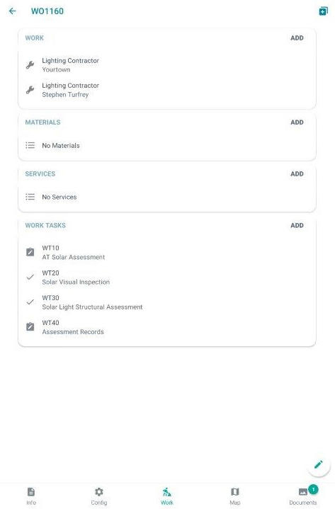

  - How to complete a Work Task – Task

Select the Task to be completed

Once in the Task, in the Work field, select Add
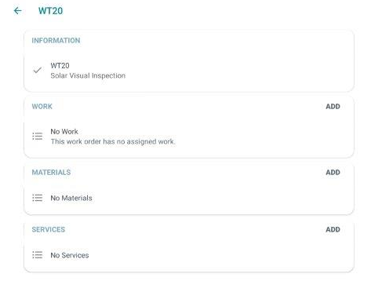

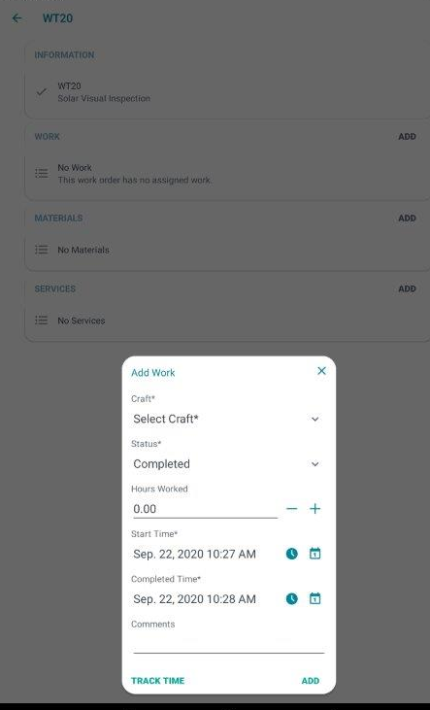

Complete all the details in the Add Work field.

- Craft – select contractor eg. AA Concrete (this may already be filled in)
- Status – change status to Completed
- Hours Worked – add total hours worked on the task
- Start time – select date and time
- Completed time – select date and time
- Comments – provide detail of the completed task
eg. replaced 3 m3 section of concrete footpath

  - How to complete a Work Task – Assessment

Select the Assessment to be completed

Select the Form and then select ASSESS
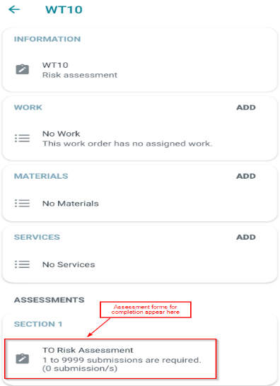
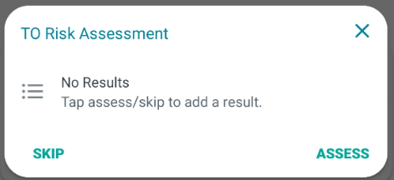

Complete all fields in the Assessment form.
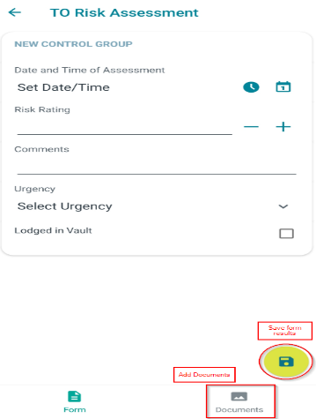
Note: the information required in an Assessment Form may vary

This example Assessment Form includes drop down and tick box items, date and time selection and free text entry

To add Documents into the Assessment Form – refer to Step 3.

Select Save 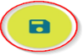
Documents Tab

The documents tab – view and add photos to the WO. (After work is completed)

- Select the camera button to add a photo
- Take a photo and agree to add it
- Enter a Label (title) for the document – optional or just leave the in date
- Group – Photo
- Category – Photo
- Sub-category should be after as the photo is taken after work has been completed
- Select Annotate to add circles or text to the photo
- Select Save
- Work Tab

The data entry for this part is mandatory for the Contractor to complete this work order
- Work – complete this now – select your craft and name to enter the job completion details
- Materials – leave blank
- Services – leave blank

Select the craft and complete all fields in the pop-up screen
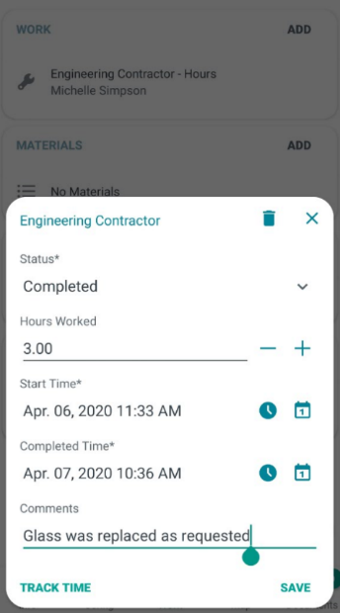
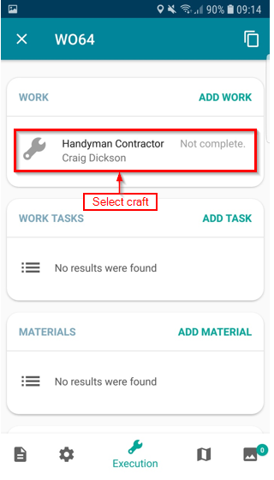

- Status – this will change to Completed once the Completed Time is entered, or change it manually
- Hours Worked – enter the total hours worked for the WO
- Start Time – enter the date and time using the calendar and clock buttons.
- Completed Time – enter the date and time using the calendar and clock buttons
- Comments – add the required completion comments with enough detail to explain what work was completed
- Select Save

- Complete the Work Order

When all WO details have been completed, select the green tick.
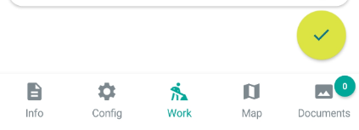

Select Complete when all the required details have been entered
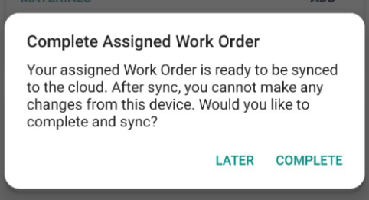

Document Control

Full instructions can be found in (WI – 603) Execute a Work Order - Mobility

Version No. | Date | Key Changes
1 | April 2020  V2.1.11 | New
2 | 2/10/2020  V2.2.0 | Minor amendments for accuracy

Back to Top (hyperlink back to top of document)

