Contractor: How to update the operating system and the Assetic app – Mobility

Summary

This Quick Reference Guide explains how to update the operating system and the Assetic app on a mobile device, including phones and tablets. This guide assume you already have a Google account or Apple ID, which are required on Android and Apple devices respectively to download and update apps and software.

Steps

Android: update the Assetic app

- Open the Play Store app.

- In Google Play menu select My apps and games

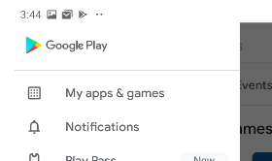

- Apps with an update available are labelled "Update."
- Select Update (if available) on the following apps:
- Google
- Google Maps
- AsseticX (if already installed)

Android: update the Play Store version

- Select either the menu button or the profile button
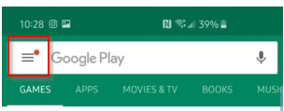
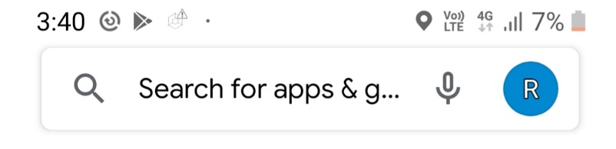

- Select Settings.

- Select Play Store version.

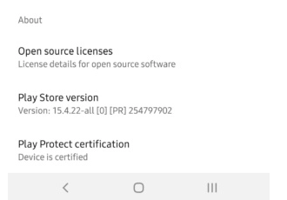

- If an update is available, it will download it. If the version is current, a message will advise ‘Google Play Store is up to date’.

Android: Update the Operating System

- Navigate to Settings
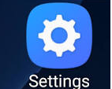
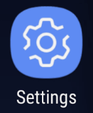

- Select Software update
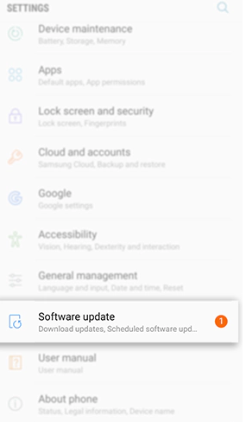

- Select Download updates manually OR Download and install
(depends on the age of the phone / tablet)

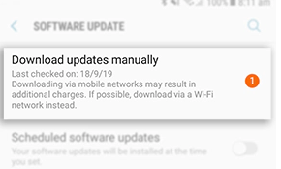

- If an update is available, select Download OR Install Now
(depends on the age of the phone / tablet)

- Continue this process until no more updates are available.

Apple: update the Assetic app

If auto updates are not enabled, follow this procedure to update the Assteic app.

- Open the App Store

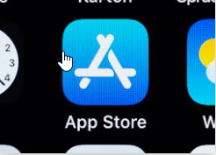

- In the search bar enter Assetic and the following screen will appear however instead of OPEN you will see UPDATE
- Press UPDATE to update the app
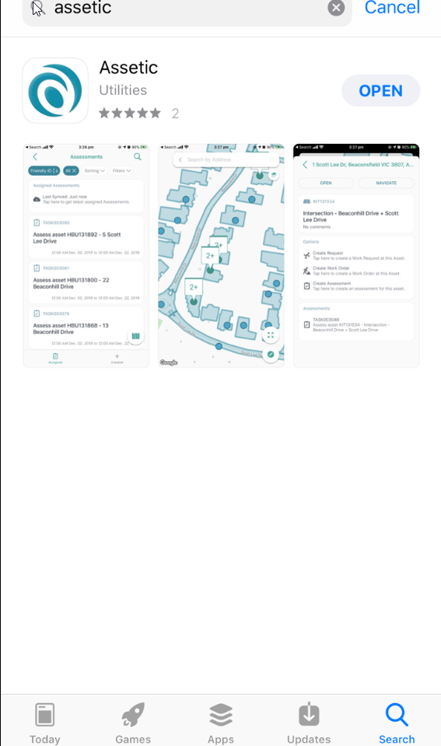

Apple: update the operating system

- First, launch the “Settings” app (the gear icon).
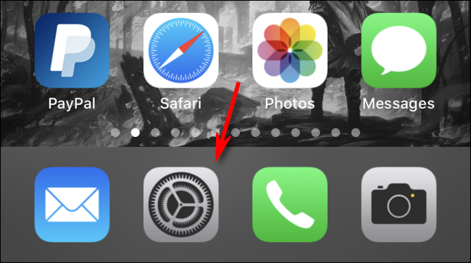

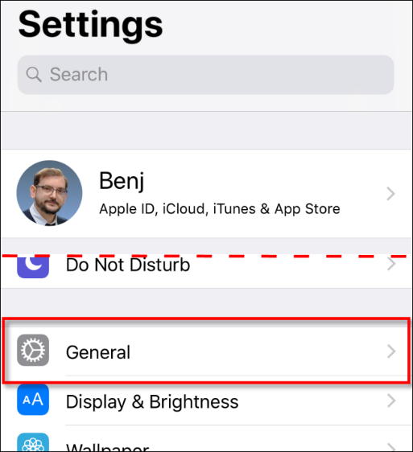

- In the Settings menu, tap “General.”

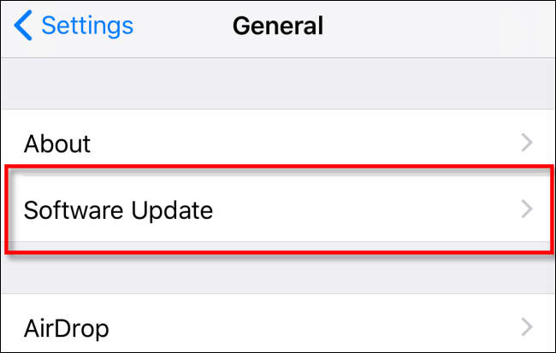
- Next, tap Software Update.

- You see information about the latest update, including the version number and details about what the update will improve.
- If your iPhone hasn’t already downloaded the update, tap Download and Install and type your passcode if it’s requested.
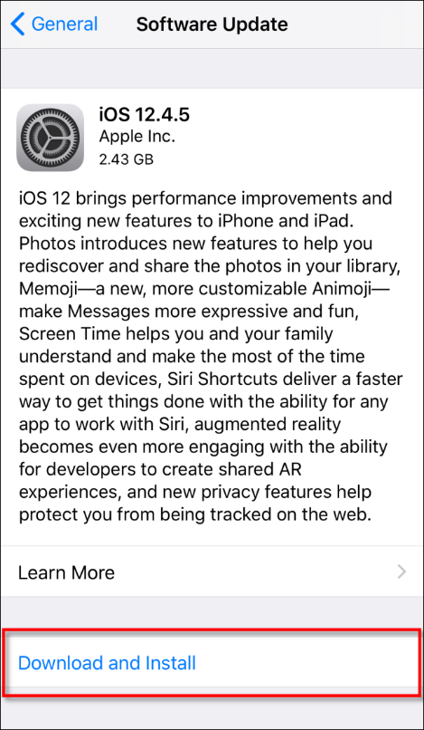
- When the update is finished downloading, a message might pop up asking whether you want to install the update now or later; tap Install Now.
- After the install process begins, you see a message that says “Verifying Update”; wait for it to finish. After verification is complete, your iPhone’s screen goes black and it will restart.
- You then see the Apple logo and a small progress bar in the centre of the screen

- When installation is complete, you can unlock and use your iPhone again as usual.

