Create Work Request – Mobility

Summary

This WI explains how to create a work request, including attaching assessments to work orders via the Assetic mobile app.

This WI has been compiled using an Android mobile device.

.

Reference Documents

WI-601 Create Work Request - Mobility

Work Instruction Steps

- Start Work Request (WR)

From the home screen, select the menu button and then select Work Request.

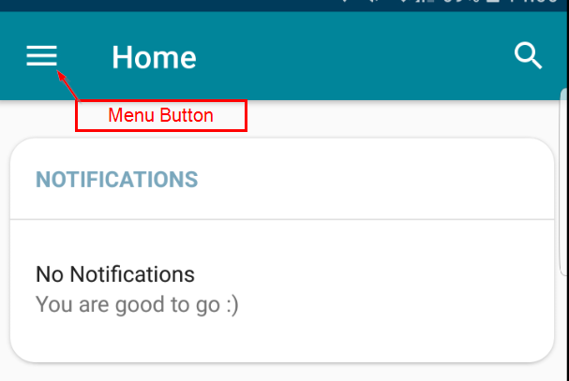

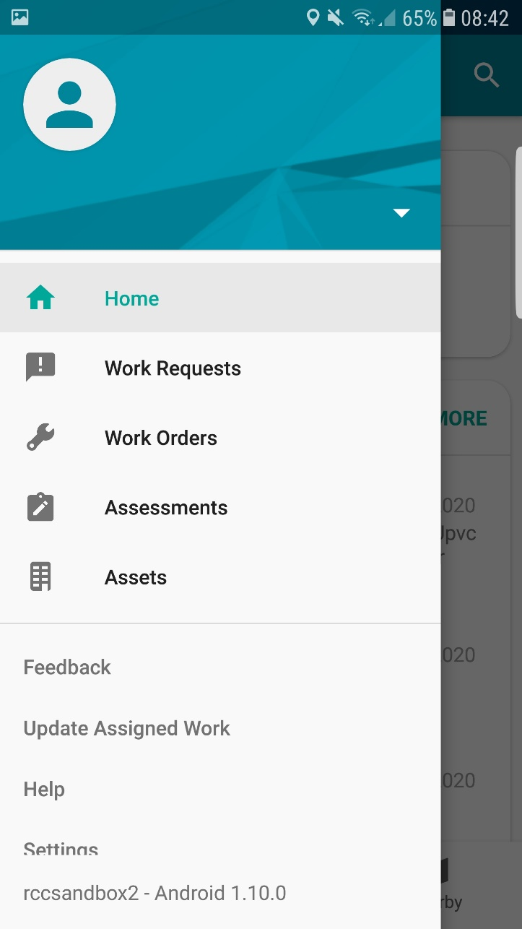

In the menu, select Work Requests Select the PLUS button to create a new WR

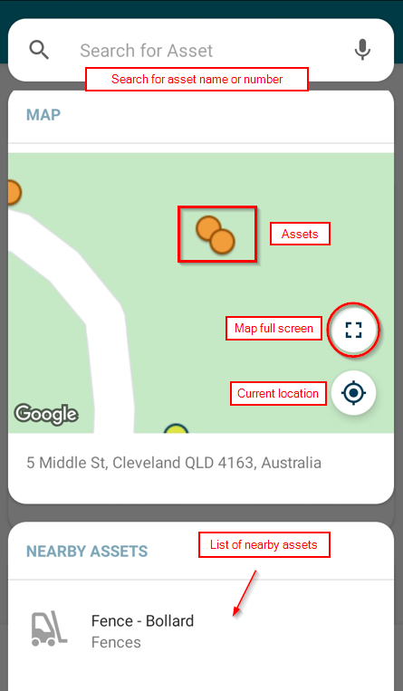

- Search / Add Asset

If you are not part of the Work Group that maintains the asset you are trying to lodge a WR for, you will not see it on the map. Skip this section if this is the case.

- Select the Search for Asset and browse the ‘Nearby Assets’ list for assets closest to you, or select Map to view nearby assets.
- Select the map full screen icon to see more assets in your current location

- You can also search for the asset by typing the asset name (or part of) or number into the search box at the top of the screen
- Select the asset name when it appears
- This will return you to the WR creations screen

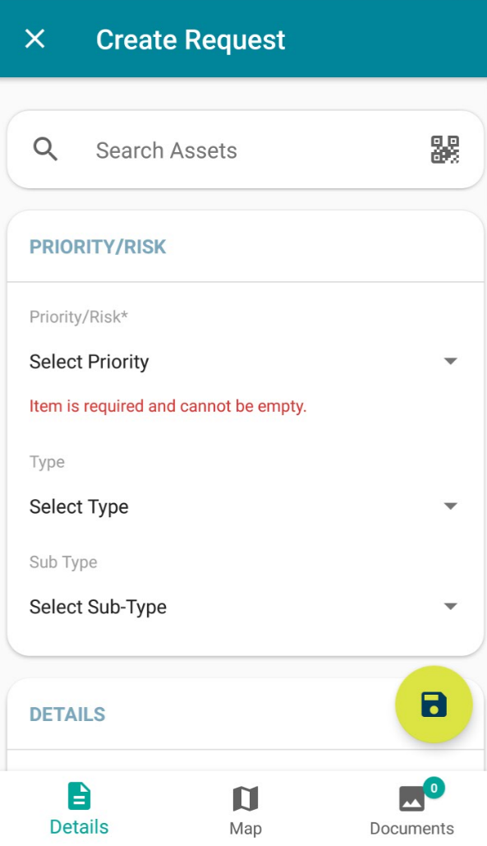

- Priority / Risk
- Select the risk / priority from the drop down menu
- Select the WR Type, either Incident, Problem or Change
- Select the WR Sub-Type from the drop down menu – this is the group responsible for maintaining the asset

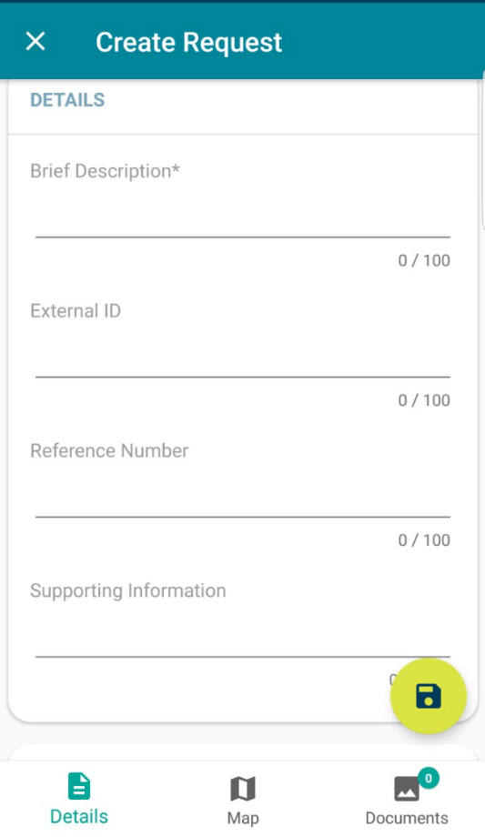

- Details / Information
- Enter a Brief Description (this is mandatory)
- Ignore External ID and Reference Number
- Enter Supporting Information (describe the issue in more detail if required to assist the triaging officer to determine the work required)

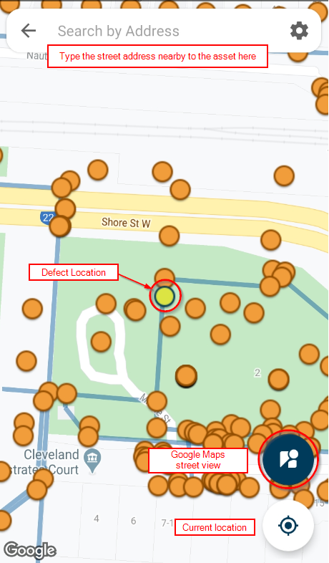

- Defect Location

If you did not select an asset, this step is required.

- If you are not in the vicinity of the defect, select the Map tab at the bottom of the screen. This will display the screen on the right
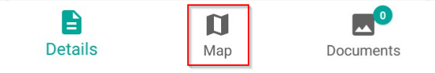

- Search for the address where the defect is located
- Once located, pinch and zoom to see greater detail on the map
- On the exact location of the defect, press and hold to pin the location of the defect (this moves the yellow dot). It may be situated at a point on the length of an asset (e.g. road or pipe)

- Documents
- Select the documents tab to upload a photo

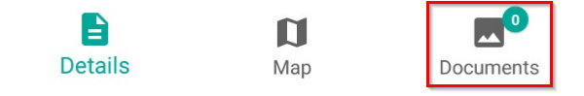

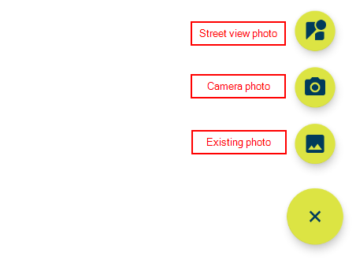
- You can upload photos in three ways, photo from the phone, take a photo or take a photo of street view
- Press the plus button to reveal the photo upload options (below)

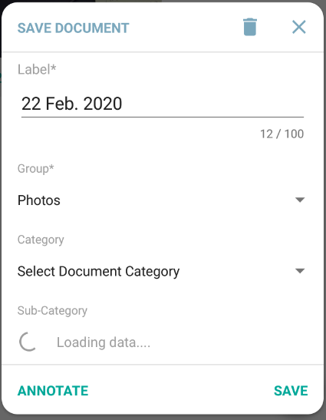
- If you select camera, take the photo and when it appears select OK to use that photo or RETRY to take it again
- When added, you will be prompted with this box
- Label contains current date and should be entered as the name of the asset
- Group is a mandatory field and will prepopulate with Photos
- Category should be selected as photos if you have taken a picture
- Sub-category will load based on Category, select the appropriate choice

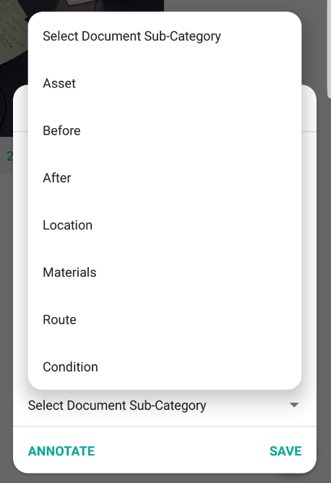

- The examples shown here are for a Category of Photos

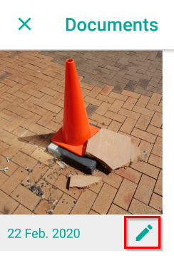

- The photo will appear on the screen with its title and an edit pencil
- Select the edit pencil to change the categories, annotate the image or delete the image
- To delete, select the trash can at the top of the pop-up
- To change the categories, choose from the drop down selections
- To Annotate, select annotate and using the drawing symbols to draw marks on the image and select the save icon when finished

To finish in documents, press the back arrow in the top left corner

- Save Work Request

- Once all work sections have been completed with relevant data, press the green Save circle/disc icon in the lower right section of the screen

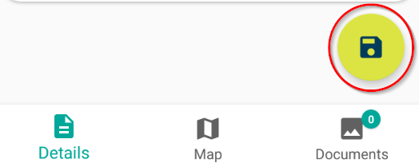

- The WR will now appear on your device with a WR number in your Created tab

Document Control

Version No. | Date | Key Changes
1 | Februrary 2020 Release 1.10.0 | New
2 | 2/10/2020 | Minor amendments for accuracy and new app features

Back to Top (hyperlink back to top of document)

