Contractor: Log into the Assetic app - Mobility

Summary

This Quick Reference Guide explains how to log into the Assetic app on a mobile device, including phones and tablets.

Steps

- Select the AsseticX app in Android to Assetic app in Apple
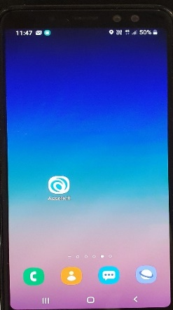

- To login, enter the domain name redland.assetic.net
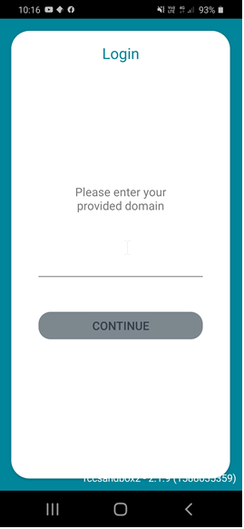
Select Continue

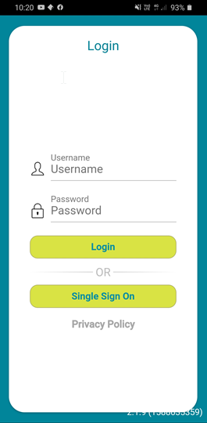

- Enter your Username and Password

- User name: type the full email address used by you for your work
eg. andy@AAconcrete.com.au

- Password: type the password
(see Contractor: How to set up a password in the
Assetic app - mobility QRG 902 to set a password)

- Select Login
- Select Continue
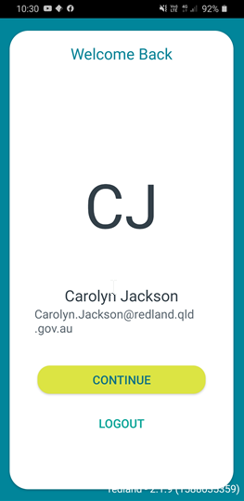

- Set up your 6 digit PIN, you must enter it twice.
- If using Apple, you may choose to use Biometrics, ie Face ID or Fingerprint – select yes when prompted

- Do not log out of the App, just close the screen after using each time.

Version No. | Date | Key Changes
1 | September 2020 | New
2 | 2/10/2020 | Amendments for accuracy

