Contractor: How to set up a password to use the Assetic app –Mobility

Summary

This Quick Reference Guide explains how to set up a password in the Assetic app on a mobile device, including phones and tablets.

**Steps**

1. To set or reset a password, open the internet browser (Chrome preferred) and type in redland.assetic.net into the address bar

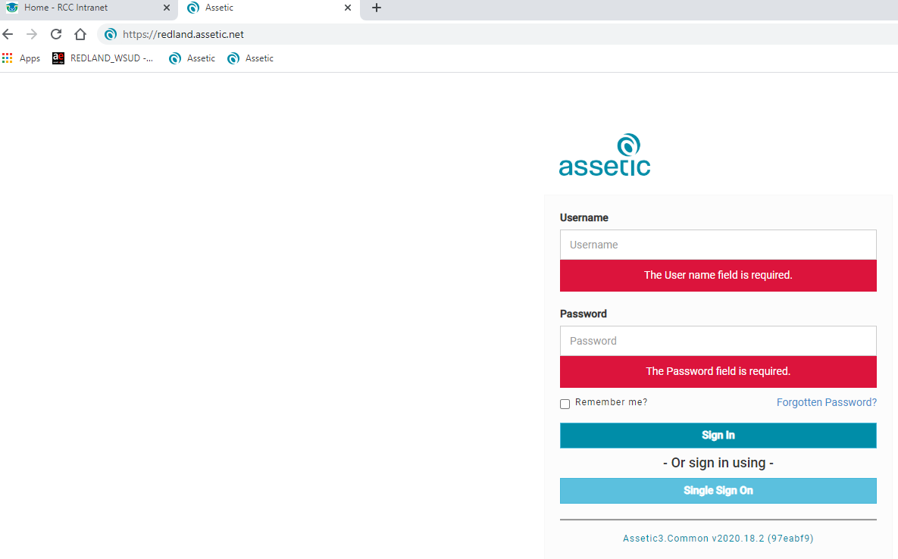

1. When loaded, click the Forgotten Password link
2. Enter the email address you use with your employer and select Reset Password

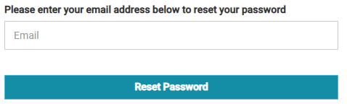

1. Close the internet browser
2. Open your email program to access your email (eg. Outlook, Gmail)
3. Wait for an email from Assetic and open it when received

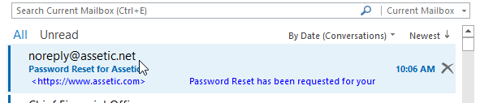

1. Select the Forgotten Password Link in the email

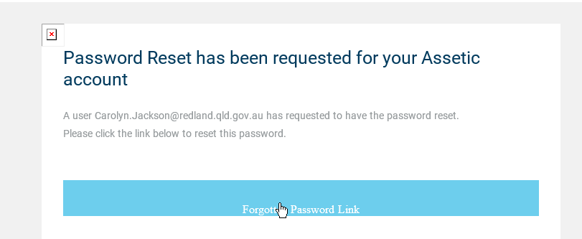

1. Enter and then confirm your new password.

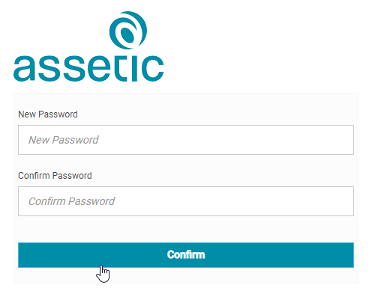

Password criteria:

* Between 8 and 32 characters
* Contain one number 0-9
* One lower case letter a-z
* One upper case letter A-Z
* One special character (!@#$%*+-)

1. Close the internet browser.
2. Open the AsseticX App (see QRG903 for how to log into the app)

Note: if you are unable to access an internet browser or have connectivity issues contact your RCC contract manager for a password reset who will organise a password for you through our IM Group. This password must be changed when you can access the internet using the same process above.

|  |  |  |
| --- | --- | --- |
| **Version No.** | **Date** | **Key Changes** |
| 1 | September 2020 | New |
| 2 | 2/10/2020 | Edits for accuracy |