Contractor: How to install the Assetic app – Mobility

Summary

This Quick Reference Guide explains how to install the Assetic app on a mobile device, including phones and tablets.

Steps

Android: install the Assetic app

- Navigate to and open the Play Store

- In the search bar enter Assetic and the following screen will appear
Select AsseticX and download the app to your device
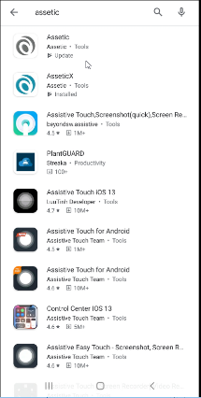

Apple: IOS install the Assetic app

- Open the App Store

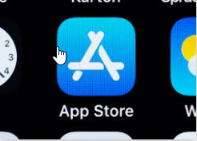

- In the search bar enter Assetic and the following screen will appear however instead of OPEN you will see a cloud with a down arrow in it or GET.
- Press the cloud with the down arrow or GET to download the app
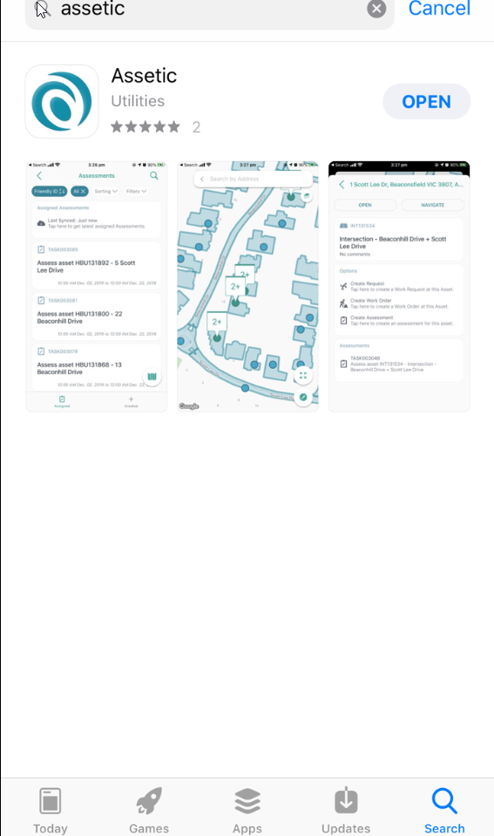

Version No. | Date | Key Changes
1 | September 2020 | New
2 | 2/10/2020 | Minor amendment to Apple download info

