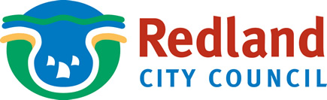

Regional Arts Development Fund (RADF) Grants

Questions to consider when you are applying for RADF grants.
Following the 2009-10 RADF Committee Annual General Meeting in November, a series of key questions were adopted to guide applicants when you are considering applying for projects for RADF assistance in Redland City.

- Does this application respond to local issues and yet retain some global relevant? (For instance; cultural diversity, current environmental issues, property development, national parks, mining, population escalation).

- Does this application utilise innovative creative techniques and mediums? (For instance; oral histories outdoor projection, digital media, collaborations, forums, experimental theatre)

- Is there an opportunity for skill sharing, mentoring or professional development with practitioners who demonstrate excellence in their field?

- Does this project assist individual and resident artists to; hone their craft, raise their profile, expand their horizons?

If you would like to discuss these questions or gain further information about RADF Grants, please contact:

Enquires: RADF Liaison Officer
Phone: 3383 2130
Email: Elaine.Seeto@redland.qld.gov.au
Web: www.redland.qld.gov.au/Grants

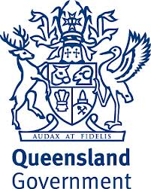
The Regional Arts Development Fund is a Queensland Government and Redland City Council partnership to support local arts and culture.

